Kia ora,

We would like to inform you about a proposed change in your neighbourhood.

Proposal:

Reference | - TR36-25 Frederick Street, Te Aro - Parking Changes
Location – where we propose to make the change | Frederick street, Te Aro, between 38-46 Frederick St and in front of 133 Taranaki located at the corner of Taranaki and Fredrick Streets.
What we’d like to do | - Install 1x P120 metered Mobility Parking.  - Retain 1x P120 metered park  - Remove 6x metered parking bays
Why we are proposing the change | - The Council is delivering the Frederick Street Park project upgrade at 129-133 Taranaki Street, providing a new central city urban park in Te Aro as part of the Green Network Plan and Our City tomorrow goals for a greener city. As part of this upgrade, Council proposes to make changes to Frederick St road corridor, to open the park into the adjoining streetscape. This proposal to remove parking bays is to enable the installation of a raingarden (water sensitive design), garden beds, additional bike parking, and an accessible mobility park. One metered parking bay is retained.  - The Council shared the parks concept design with the public in October 2023. Engagement showed 96% public support for the proposed design which included proposed changes to Frederick Street road corridor.  - Frederick St Park project Let’s Talk page: Frederick Street Park Upgrades | Let's Talk. This includes a Concept Design Engagement Report.  - This Traffic resolution is focused on changes to parking provisions on Frederick Street only and does not extend to feedback related to the park projects design.  - Provision for a mobility parking bay in this area fills a need within southeast Te Aro.
Impact | Improvements  - Improves safety and accessibility for mobility park users. Providing for a gap in southeast Te Aro.  - Alternative modes of transport supported with provision of bike parking.  - Improved visibility into the proposed park site, opening site lines through reduction in parking bays.  - Additional greening and safer pedestrian environment adjoining the proposed park site.  Net Parking Impact  - Removal of (6#) parking spaces (metered parking)  - Converting of (1#) parking spaces (metered mobility parking)  - Relocation of (1#) parking spaces (metered parking)  Pedestrian impact  - This is a positive result as this change will open visibility into the park from the adjoining streetscape, increasing natural surveillance and safety. Improved pedestrian priority environment and supporting alternative modes of transport (walking/cycling).
How this relates to the parking policy | - Support shift in type of transport used – facilitate a shift to using active (eg, walking and cycling) and public transport, to move more people driving fewer vehicles.  - Support safe movement – facilitate the safe and efficient movement of people and goods by focusing on people moving along transport corridors rather than people parking or storing stationary vehicles.  - Support city place-making, amenity and safety – ensure on-street parking design and placement supports overall city amenity, safety, community building, heritage, creative arts, good urban design outcomes and attractive streetscapes.  - Support a move to becoming an eco-city. To facilitate the uptake of car sharing, electric vehicles and other transport with low carbon emissions. Manage parking and incentivise a decrease in vehicle use to contribute to a reduced carbon 12 Parking Policy August 2020 emissions, better water quality, air quality, stormwater management and biodiversity outcomes.  - Support access for all – ensure disabled people, older people, people who are pregnant, and people with babies can access the city, Council facilities, and venues. This will be achieved, in part, through an improvement in mobility parking across the city.
Additional Information | - Average daily traffic count – 1,053 (2021 Data)  - Annual parking revenue impact - Removal of 6x parking bays results in an annual parking revenue reduction of $23,391.77.  - To view the legal description for this Traffic Resolution, an electronic copy of the report will be available on the Council’s website from 9.00am Wednesday 30 April at https://www.letstalk.wellington.govt.nz/ or you can call (04) 499 4444 and we will send one out to you.
Privacy | - Your privacy is important to us. Please DO NOT add specific personal details to your feedback (i.e.: full name, address, etc)  - What we do with your personal information:  All submissions (including your first name, but not contact details) are provided in their entirety to elected members and made available to the public on our website and at our office. Personal information (including contact details) will also be used for the administration of the consultation process including informing you of the outcome of the consultation. All information collected will be held by Wellington City Council, 113 The Terrace, Wellington, with submitters having the right to access and correct personal information.  - For more information regarding our Privacy Statement please check our webpage: Privacy statement - Wellington City Council.
Feedback | - If you would like to provide us with specific feedback, which will be added to the Traffic Resolution following consultation and made public in full, you can do so by filling out an online submission form, downloading a printable submission form on https://www.letstalk.wellington.govt.nz/ or emailing us at trfeedback@wcc.govt.nz.  Please note if you are giving feedback the consultation period opens at 9.00 am Wednesday 30 April and finishes at 5.00 pm Wednesday 14 May 2025.
Next Steps | - Feedback collated by Thursday 15 May.  - The proposal will go to the Koata Hātepe|Regulatory Processes Committee meeting on Thursday 18 June 2025.  - If approved, the proposal will be installed as part of the Frederick St Park project construction (within 6-8 months)

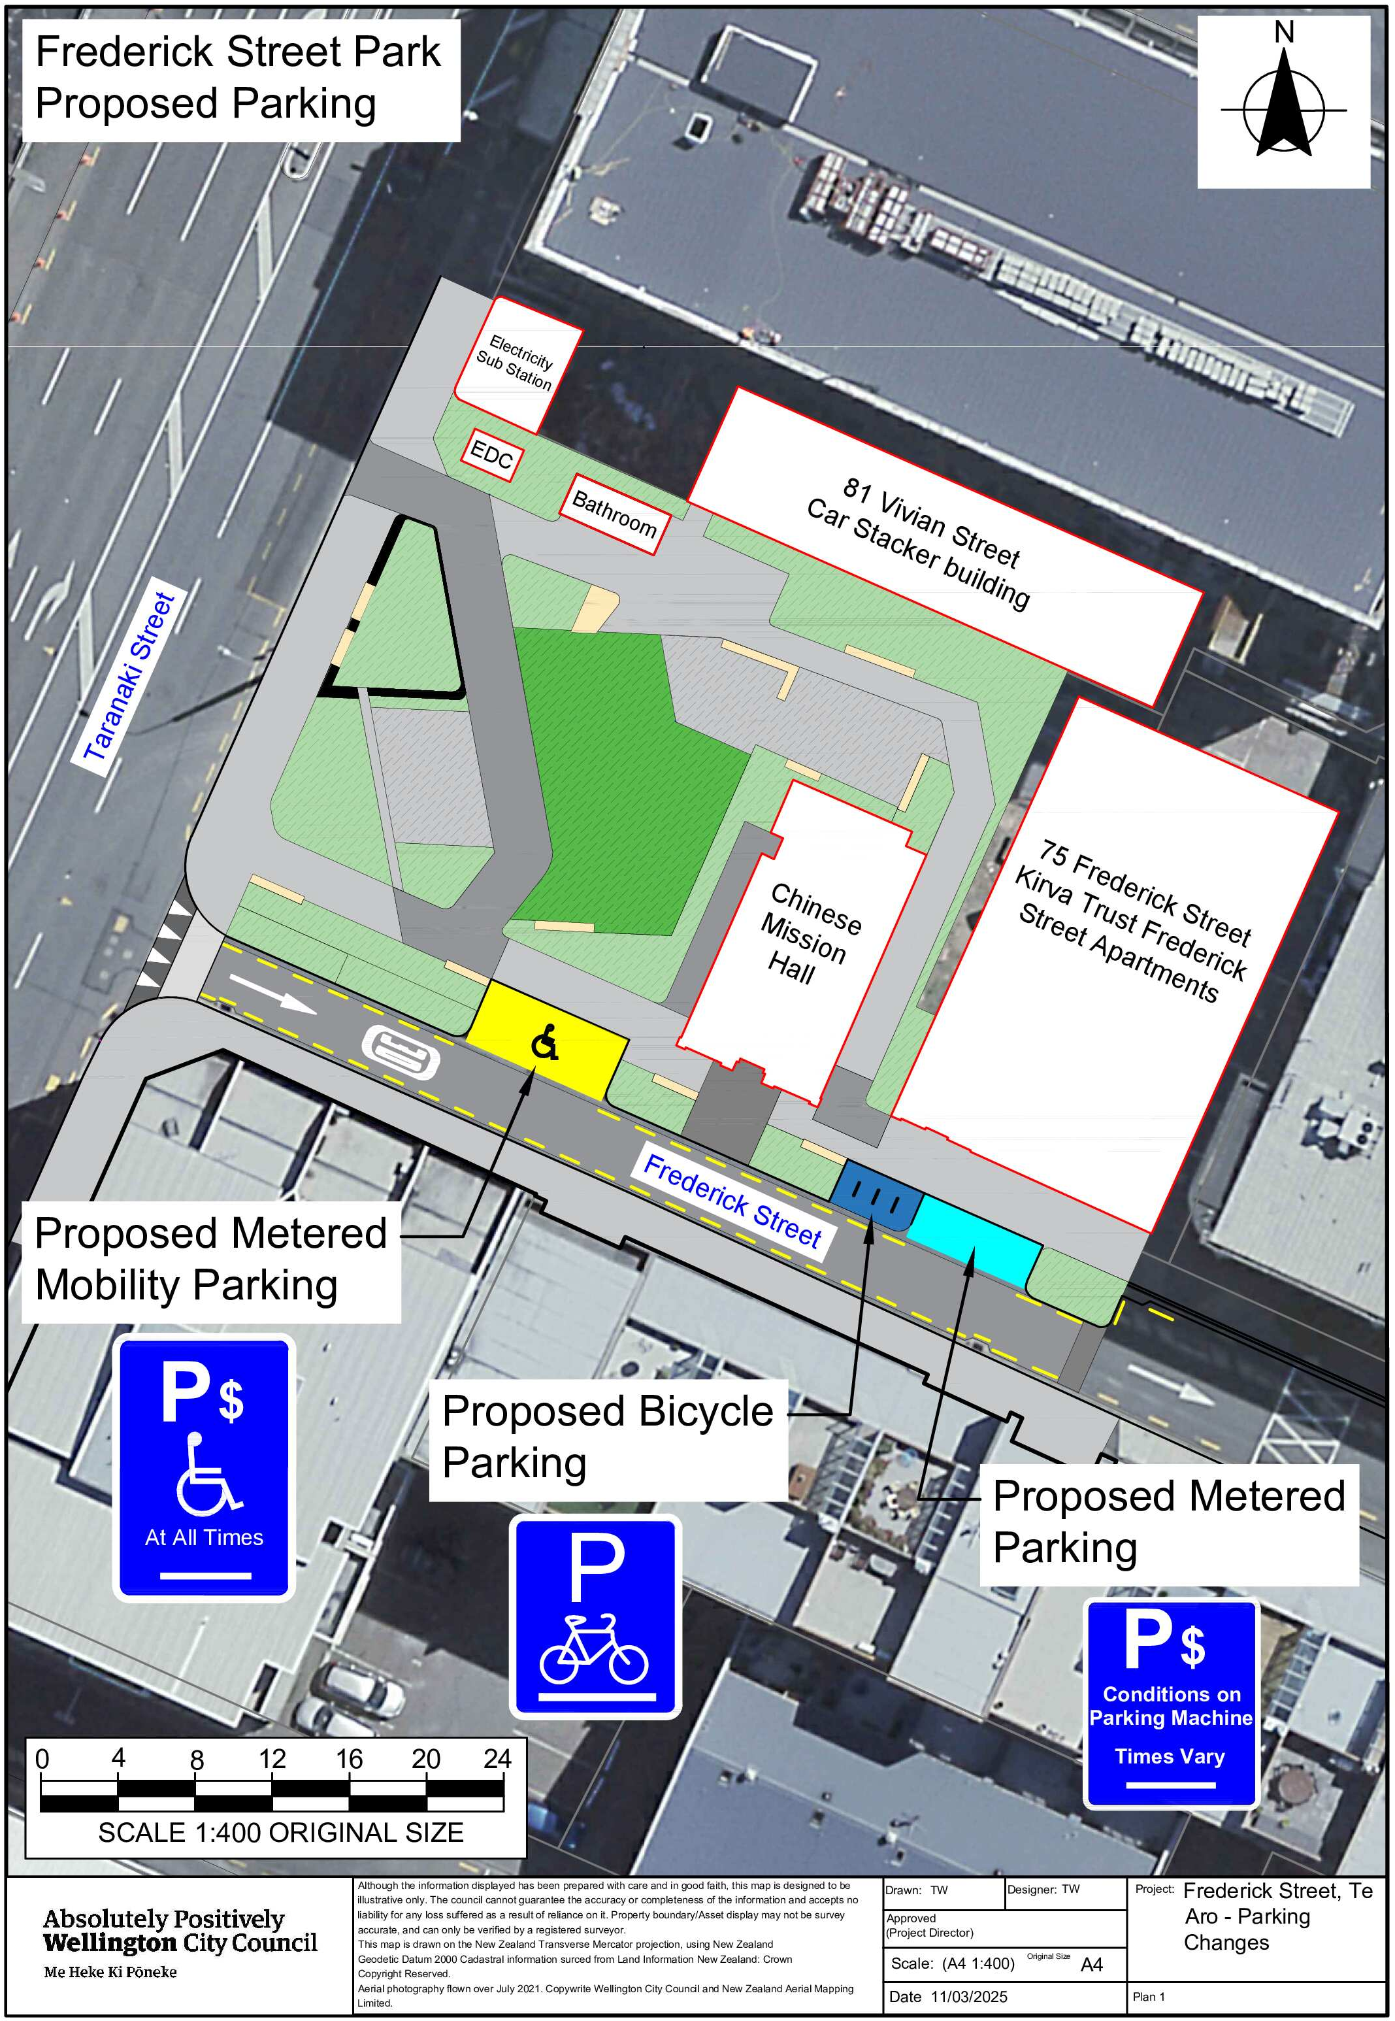
Traffic Resolution Plan: TR36-25 Frederick Street, Te Aro - Parking Changes

Legal Description:

Delete to Schedule F (Metered Parking) of the Traffic Restrictions Schedule

Column One | Column Two | Column Three
Frederick Street | P120 Maximum, Monday to Thursday 8:00am - 6:00pm, Friday 8:00am - 8:00pm, Saturday and Sunday 8:00 - 6:00pm | Northeast side, commencing 6.5 metres southeast of its intersection with Taranaki Street (Grid coordinates x= 1748776.0 m, y= 5426853.4 m), and extending in a south-easterly direction following the kerbline for 28 metres. (5 parallel carparks)
Frederick Street | Metered Parking, Monday to Friday P120 Maximum 8:00am – 5:00pm, P180 Maximum 5:00pm - 8:00pm, Saturday to Sunday P180 Maximum 8:00am – 8:00pm | North side, commencing 34.5 metres east of its intersection with Frederick Street (Grid coordinates X=1,748,775.95m Y=5,426,853.10m) and extending in an easterly direction following the northern kerb line for 19 metres.

Delete to Schedule D (No Stopping) of the Traffic Restrictions Schedule

Column One | Column Two | Column Three
Frederick Street | No Stopping at All Times | Northeast side, commencing from its intersection with Taranaki Street (Grid Coordinates X=2658798.015701 m, Y=5988565.512014 m) and extending in a south-easterly direction following the kerbline for 6.5 metres.

Add to Schedule B (Class Restricted) of the Traffic Restrictions Schedule

Column One | Column Two | Column Three
Frederick Street | Metered Mobility Parking At All Times, Displaying an Operation Mobility Permit Only | Northeast side, commencing 16.5 metres east of its intersection with Taranaki Street (Grid coordinates X= 1,748,776.39, Y= 5,426,851.74), and extending in an easterly direction following the northern kerbside for 7.7 metres.

Add to Schedule B (Class Restricted) of the Traffic Restrictions Schedule

Column One | Column Two | Column Three
Frederick Street | Bicycle Parking At All Times | Northeast side, commencing 37 metres east of its intersection with Taranaki Street (Grid coordinates X= 1,748,776.39, Y= 5,426,851.74), and extending in an easterly direction following the northern kerbside for 4.5 metres.

Add to Schedule F (Metered Parking) of the Traffic Restrictions Schedule

Column One | Column Two | Column Three
Frederick Street | Metered Parking  Monday to Friday P120 Maximum 8:00am – 5:00pm,  P180 Maximum 5:00pm - 8:00pm, Saturday to Sunday P180 Maximum 8:00am – 8:00pm | Northeast side, commencing 41.5 metres east of its intersection with Taranaki Street (Grid coordinates X= 1,748,776.39, Y= 5,426,851.74), and extending in an easterly direction following the northern kerbside for 6.5 metres.

Add to Schedule D (no Stopping) of the Traffic Restrictions Schedule

Column One | Column Two | Column Three
Frederick Street | No Stopping At All Times | Northeast side, commencing 3 metres east of its intersection with Taranaki Street (Grid coordinates X= 1,748,776.39, Y= 5,426,851.74), and extending in an easterly direction following the northern kerbside for 13 metres.
Frederick Street | No Stopping At All Times | Northeast side, commencing 24 metres east of its intersection with Taranaki Street (Grid coordinates X= 1,748,776.39, Y= 5,426,851.74), and extending in an easterly direction following the northern kerbside for 17 metres.
Frederick Street | No Stopping At All Times | Northeast side, commencing 48 metres east of its intersection with Taranaki Street (Grid coordinates X= 1,748,776.39, Y= 5,426,851.74), and extending in an easterly direction following the northern kerbside for 7 metres.
Frederick Street | No Stopping At All Times | Southeast side, commencing 3 metres east of its intersection with Taranaki Street (Grid coordinates X= 1,748,773.87, Y= 5,426,846.07), and extending in an easterly direction following the northern kerbside for 58 metres.

Prepared By: | Stephanie O’Shea | (Senior Urban Designer)
Approved By: | Kate Gourdie | (Team Leader Traffic & Resolutions)
Approved Date: | 10/04/2025

