Kia ora,

We would like to inform you about a proposed change in your neighbourhood.

Proposal:

Reference | - TR61-26 Brussels Street, Miramar- Formalise Give Way control
Location – where we propose to make the change | - Brussels Street, Miramar – Outside no. 1 to 76.
What we’d like to do | - Formalise existing give way controls along Brussels Street and install missing signs and road markings.
Why we are proposing the change | - At the intersections of Brussels Street with Tauhinu Road/Park Road and Para Street historically those vehicles on Brussels Street must yield to vehicles travelling on the roads identified above.  - Upon inspection it has been found that these intersections, while containing some elements that are required for a give way control, such as signs and road markings, are each missing at least one element required to make it complaint with NZTA legislation and have not been formalised in our database.  - Therefore, this traffic resolution is to formalise the de-facto give way controls along Brussels Street which are in place and to bring them up to national standard by installing the missing elements that have been identified.  - To improve safety and consistency across the roading network we are proposing to bring the existing intersections up to standard regarding give way controls and have them agreed upon by council.
Impact | Improvements  - Improves safety for all road users  Net Parking Impact  - No Change  Pedestrian impact  - No Change
Additional Information | - Average daily traffic count – 2,835 (2021)  - An electronic copy of the report will be available on the Council’s website from 9.00am 10 June 2026 at https://www.letstalk.wellington.govt.nz/
Privacy | - Your privacy is important to us. Please DO NOT add specific personal details to your feedback (i.e.: full name, address, etc)  - What we do with your personal information:  All submissions (including your first name, but not contact details) are provided in their entirety to elected members and made available to the public on our website and at our office. Personal information (including contact details) will also be used for the administration of the consultation process including informing you of the outcome of the consultation. All information collected will be held by Wellington City Council, with submitters having the right to access and correct personal information.  - For more information regarding our Privacy Statement please check our webpage: Privacy statement - Wellington City Council.
Feedback | - If you would like to provide us with specific feedback, which will be added to the Traffic Resolution following consultation and made public in full, you can do so by filling out an online submission form, downloading a printable submission form on https://www.letstalk.wellington.govt.nz/ or emailing us at trfeedback@wcc.govt.nz.  Please note if you are giving feedback the consultation period opens at 9.00 am 10 June 2026 and finishes at 5.00 pm 24 June 2026.
Next Steps | - Feedback collated by 25 June 2026.  - The proposal will go to the Te Takere|Regulatory Processes Committee meeting on 5 August 2026.  - If approved, the proposal will be installed within the following six months.

Traffic Resolution Plan: TR61-26 Brussels Street, Miramar– Formalise Give Way Control

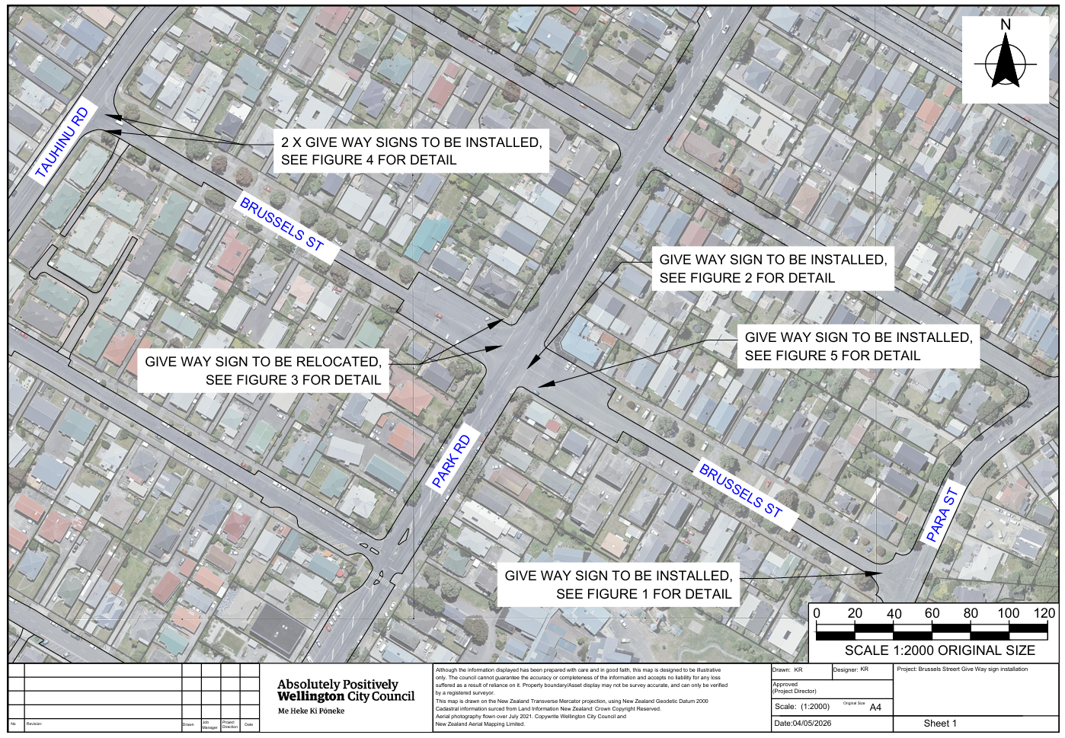

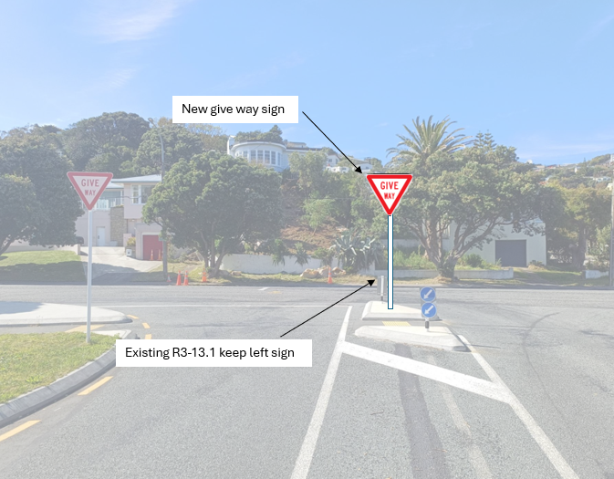

Figure 1

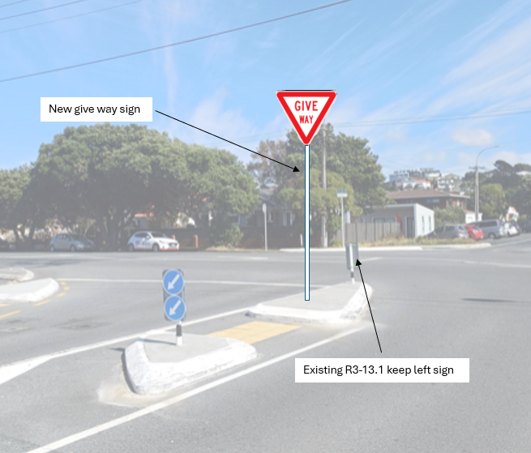

Figure 2
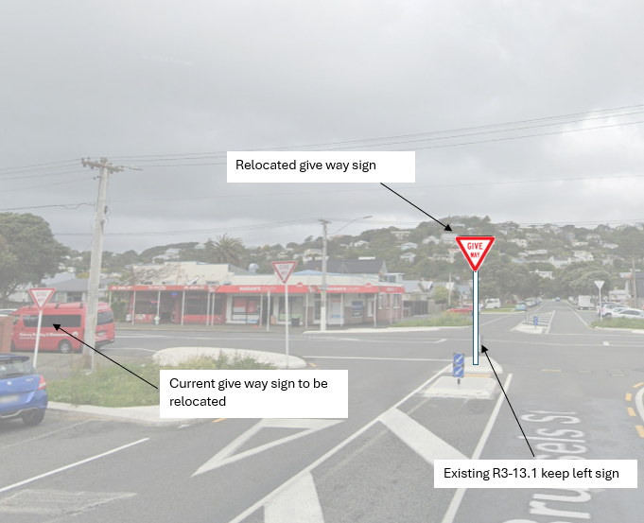

Figure 3
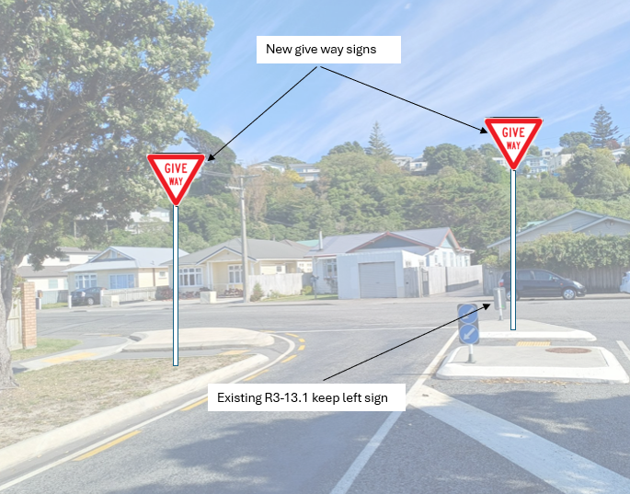

Figure 4
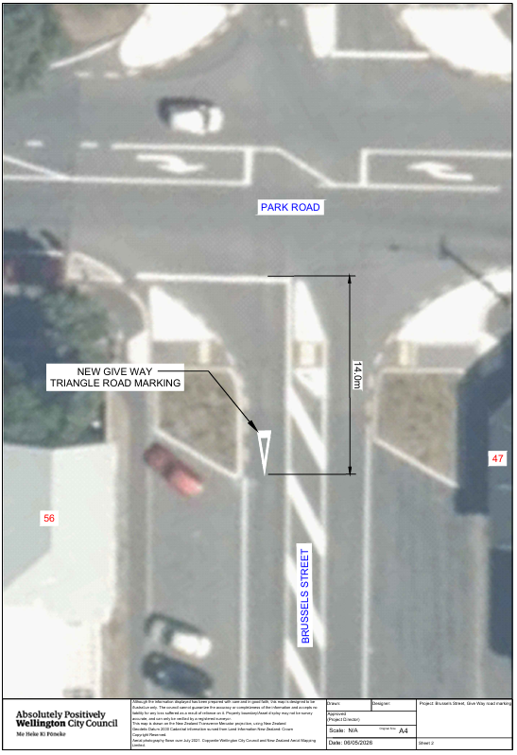

Figure 5
Legal Description:

Add to Schedule G (Give Way) of the Traffic Restrictions Schedule

Column One | Column Two | Column Three
Brussels Street | Give Way Control | At its western approach to its intersection  with Tauhinu Street
Brussels Street | Give Way Control | At its eastern approach to its intersection  with Park Road
Brussels Street | Give Way Control | At its western approach to its intersection  with Park Road
Brussels Street | Give Way Control | At its eastern approach to its intersection  With Para Street

Prepared By: | Karl Rudge | (Transport Engineer)
Approved By: | Kate Gourdie | (Team Leader Traffic & Resolutions)
Approved Date: | 29/05/2026

