Kia ora,

This leaflet is to let you know about a change we are proposing to make in your neighbourhood.

Proposal:

Reference | - TR60-26 Medway Street, Island Bay – P60 Time Limited Parking
Location – where we propose to make the change | Medway Street, Island Bay – outside nos. 8 - 14
What we’d like to do | - Convert Bus Stop At All Times to P60 Time Limited Parking, Monday to Sunday 8:00am – 6:00pm
Why we are proposing the change | - Wellington City Council has received a request from Greater Wellington Regional Council (GWRC) regarding the former Medway Street bus stop, located outside New World supermarket Island Bay.  - As of 25 January 2026, this bus stop is no longer included in Metlink bus routes 29 and 39. This is because these services were rerouted from the north section of Derwent Street due to vibration issues resulting from passing Metlink buses.  - With the Medway Street bus stop no longer being in operation, GWRC has requested that the bus stop restriction be formally removed and converted to time limited parking so that this kerb space may better serve the surrounding shopping and residential area.  - Therefore, officers propose to convert the former bus stop and its entry taper (9 metres of No Stopping At All Times) into P60 time limited parking, Monday to Sunday 8:00am – 6:00pm.  - This time restriction has been proposed in line with the other nearby P60 time limited parking spaces on Medway Street, creating an additional four P60 parking spaces in this location to be utilised by visitors to the area and residents.
Impact | Improvements  - Improves parking availability for businesses and residents  - Formalises removal of the former Medway Street bus stop’s restriction  Net Parking Impact  - Addition of four P60 Time Limited parking spaces  Pedestrian impact  - No change
Other options considered | - Option 1: Convert the former bus stop into unrestricted on-street parking. This option is not preferred as it would not allow for turnover of these parking spaces, limiting parking availability in this area.  - Option 2: Convert the former bus stop into P60 time limited parking, at all times. This option is not preferred as this would prohibit the use of these parking spaces by residents during overnight off-peak business hours, when a P60 time limited restriction would serve minimal purpose.
How this relates to the parking policy | - Support business wellbeing – ensure parking management and pricing controls support economic activity in the central city, suburban centres and mobile trades and services.  - Support city place-making, amenity and safety – ensure on-street parking design and placement supports overall city amenity, safety, community building, heritage, creative arts, good urban design outcomes and attractive streetscapes.
Additional Information | - Average daily traffic count - 4377 (2024 count)  - Annual parking revenue impact – No change.  - To view the legal description for this Traffic Resolution, an electronic copy of the report will be available on the Council’s website from 9.00am 10 June 2026 at https://www.letstalk.wellington.govt.nz/
Privacy | - Your privacy is important to us. Please DO NOT add specific personal details to your feedback (i.e.: full name, address, etc)  - What we do with your personal information:  All submissions (including your first name, but not contact details) are provided in their entirety to elected members and made available to the public on our website and at our office. Personal information (including contact details) will also be used for the administration of the consultation process including informing you of the outcome of the consultation. All information collected will be held by Wellington City Council, with submitters having the right to access and correct personal information.  - For more information regarding our Privacy Statement please check our webpage: Privacy statement - Wellington City Council.
Feedback | - If you would like to provide us with specific feedback, which will be added to the Traffic Resolution following consultation and made public in full, you can do so by filling out an online submission form, downloading a printable submission form on https://www.letstalk.wellington.govt.nz/ or emailing us at trfeedback@wcc.govt.nz.  Please note if you are giving feedback the consultation period opens at 9.00 am 10 June 2026 and finishes at 5.00 pm 24 June 2026.
Next Steps | - Feedback collated by 25 June 2026.  - The proposal will go to the Te Takere|Regulatory Processes Committee meeting on 5 August 2026.  - If approved, the proposal will be installed within the following six months.

Traffic Resolution Plan: TR60-26 Medway Street, Island Bay – P60 Time Limited Parking

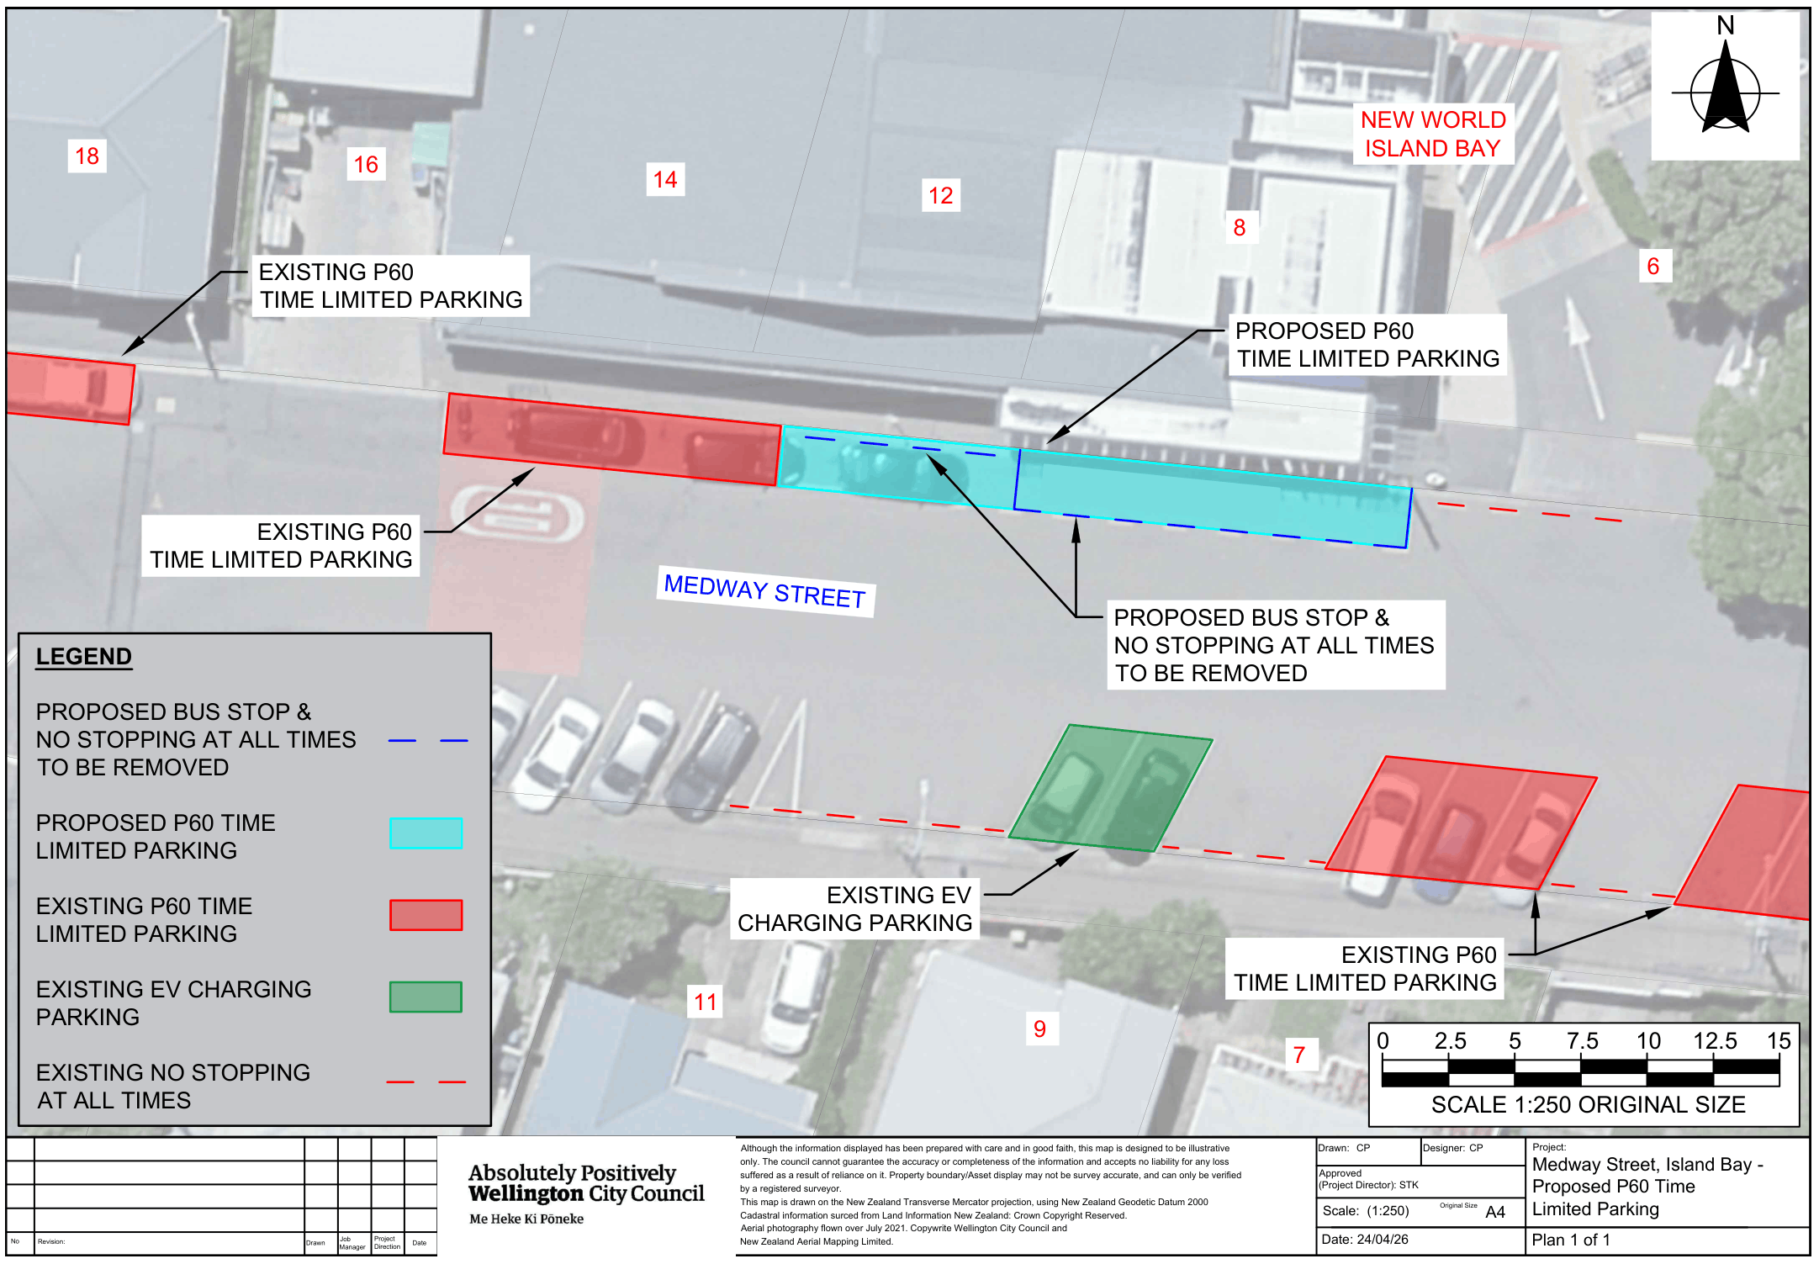

Legal Description:

Delete from Schedule A (Time Limited) of the Traffic Restrictions Schedule

Column One | Column Two | Column Three
Medway Street | P60  Monday to Sunday, 8:00am – 6:00pm | North side, commencing 65 metres west of its intersection with The Parade (Grid coordinates x=1748381.4 m, y=5422559.7m), and extending in a westerly direction following the northern kerb line for 17 metres.

Delete from Schedule B (Class Restricted) of the Traffic Restrictions Schedule

Column One | Column Two | Column Three
Medway Street | Bus Stop At All Times | North side, commencing 36 metres east of its  intersection with Derwent Street (Grid  coordinates X=1748336.2525,  Y=5422565.3778) and extending in an  easterly direction following the northern  kerbline for 15 metres.

Delete from Schedule D (No Stopping) of the Traffic Restrictions Schedule

Column One | Column Two | Column Three
Medway Street | No Stopping At All Times | North side, commencing 27 metres east of  its intersection with Derwent Street (Grid  coordinates X=1748313.059273,  Y=5422567.606703) and extending in an  easterly direction following the northern  kerbline for 9 metres.

Add to Schedule A (Time Limited) of the Traffic Restrictions Schedule

Column One | Column Two | Column Three
Medway Street | P60  Monday to Sunday, 8:00am – 6:00pm | North side, commencing 51.6 metres West of its intersection with The Parade (Grid coordinates X= 1,748,388.03m, Y= 5,422,564.84m) and extending in a westerly direction following the northern kerbline for 37 metres.

Prepared By: | Charlotte Poi | (Transport Engineer Assistant)
Approved By: | Kate Gourdie | (Team Leader Traffic & Resolutions)
Approved Date: | 19/05/2026

