Kia ora,

We would like to inform you about a proposed change in your neighbourhood.

Proposal:

Reference | TR38-25 Stewart Drive, Newlands - Bus Stop Formalisation (#3404)
Location – where we propose to make the change | Stewart Drive, Newlands – outside #64
What we’d like to do | Formalise Bus Stop #3404 by installing adequate road markings.
Why we are proposing the change | - Council has received safety concerns regarding drivers turning out of Padnell Crescent onto Stewart Drive, where low visibility of oncoming traffic traveling eastward on Stewart Drive poses a risk.  - To address this, Council officers are proposing to formalise the existing bus stop at this location. This will ensure that vehicles do not park in this location, improving sight lines and enhancing safety for vehicles turning from Padnell Crescent.  - As part of these changes, entry and exit tapers have been included to enhance bus access in and out of the bus stop.
Impact | Improvements  - Improves safety and accessibility for drivers at the intersection  - Improves bus service  - Improves safer turning movements  - Improves driver visibility  Net Parking Impact  - No change with the existing Bus Stop and vehicle driveways  Pedestrian impact  - Positive with improved bus stop layout
How this relates to the parking policy | - Support shift in type of transport used – facilitate a shift to using active (eg, walking and cycling) and public transport through parking management and pricing, to move more people driving fewer vehicles.  - Support safe movement – facilitate the safe and efficient movement of people and goods by focusing on people moving along transport corridors rather than people parking or storing stationary vehicles.  - Support move to becoming an eco-city – facilitate the uptake of car sharing, electric vehicles and other transport with low carbon emissions. Manage parking and incentivise a decrease in vehicle use to contribute to a reduced carbon 12 Parking Policy August 2020 emissions, better water quality, air quality, stormwater management and biodiversity outcomes
Additional Information | - Average monthly passenger number - Stop 3404: 9 Boarding, 1,668 Alighting (March 2025)  - Average daily traffic count – 1,121 (Padnell Cres) / 7,048 (Stewart Drive)  - To view the legal description for this Traffic Resolution, an electronic copy of the report will be available on the Council’s website from 9.00am Wednesday 30 April 2025 at https://www.letstalk.wellington.govt.nz/ or you can call (04) 499 4444 and we will send one out to you.
Privacy | - Your privacy is important to us. Please DO NOT add specific personal details to your feedback (i.e.: full name, address, etc)  - What we do with your personal information:  All submissions (including your first name, but not contact details) are provided in their entirety to elected members and made available to the public on our website and at our office. Personal information (including contact details) will also be used for the administration of the consultation process including informing you of the outcome of the consultation. All information collected will be held by Wellington City Council, 113 The Terrace, Wellington, with submitters having the right to access and correct personal information.  - For more information regarding our Privacy Statement please check our webpage: Privacy statement - Wellington City Council.
Feedback | - If you would like to provide us with specific feedback, which will be added to the Traffic Resolution following consultation and made public in full, you can do so by filling out an online submission form, downloading a printable submission form on https://www.letstalk.wellington.govt.nz/ or emailing us at trfeedback@wcc.govt.nz.  Please note if you are giving feedback the consultation period opens at 9.00am Wednesday 30 April 2025 and finishes at 5.00pm Wednesday 14 May 2025.
Next Steps | - Feedback collated by Thursday 15 April 2025.  - The proposal will go to the Koata Hātepe|Regulatory Processes Committee meeting on Wednesday 18 June 2025.  - If approved, the proposal will be installed within the following three months.

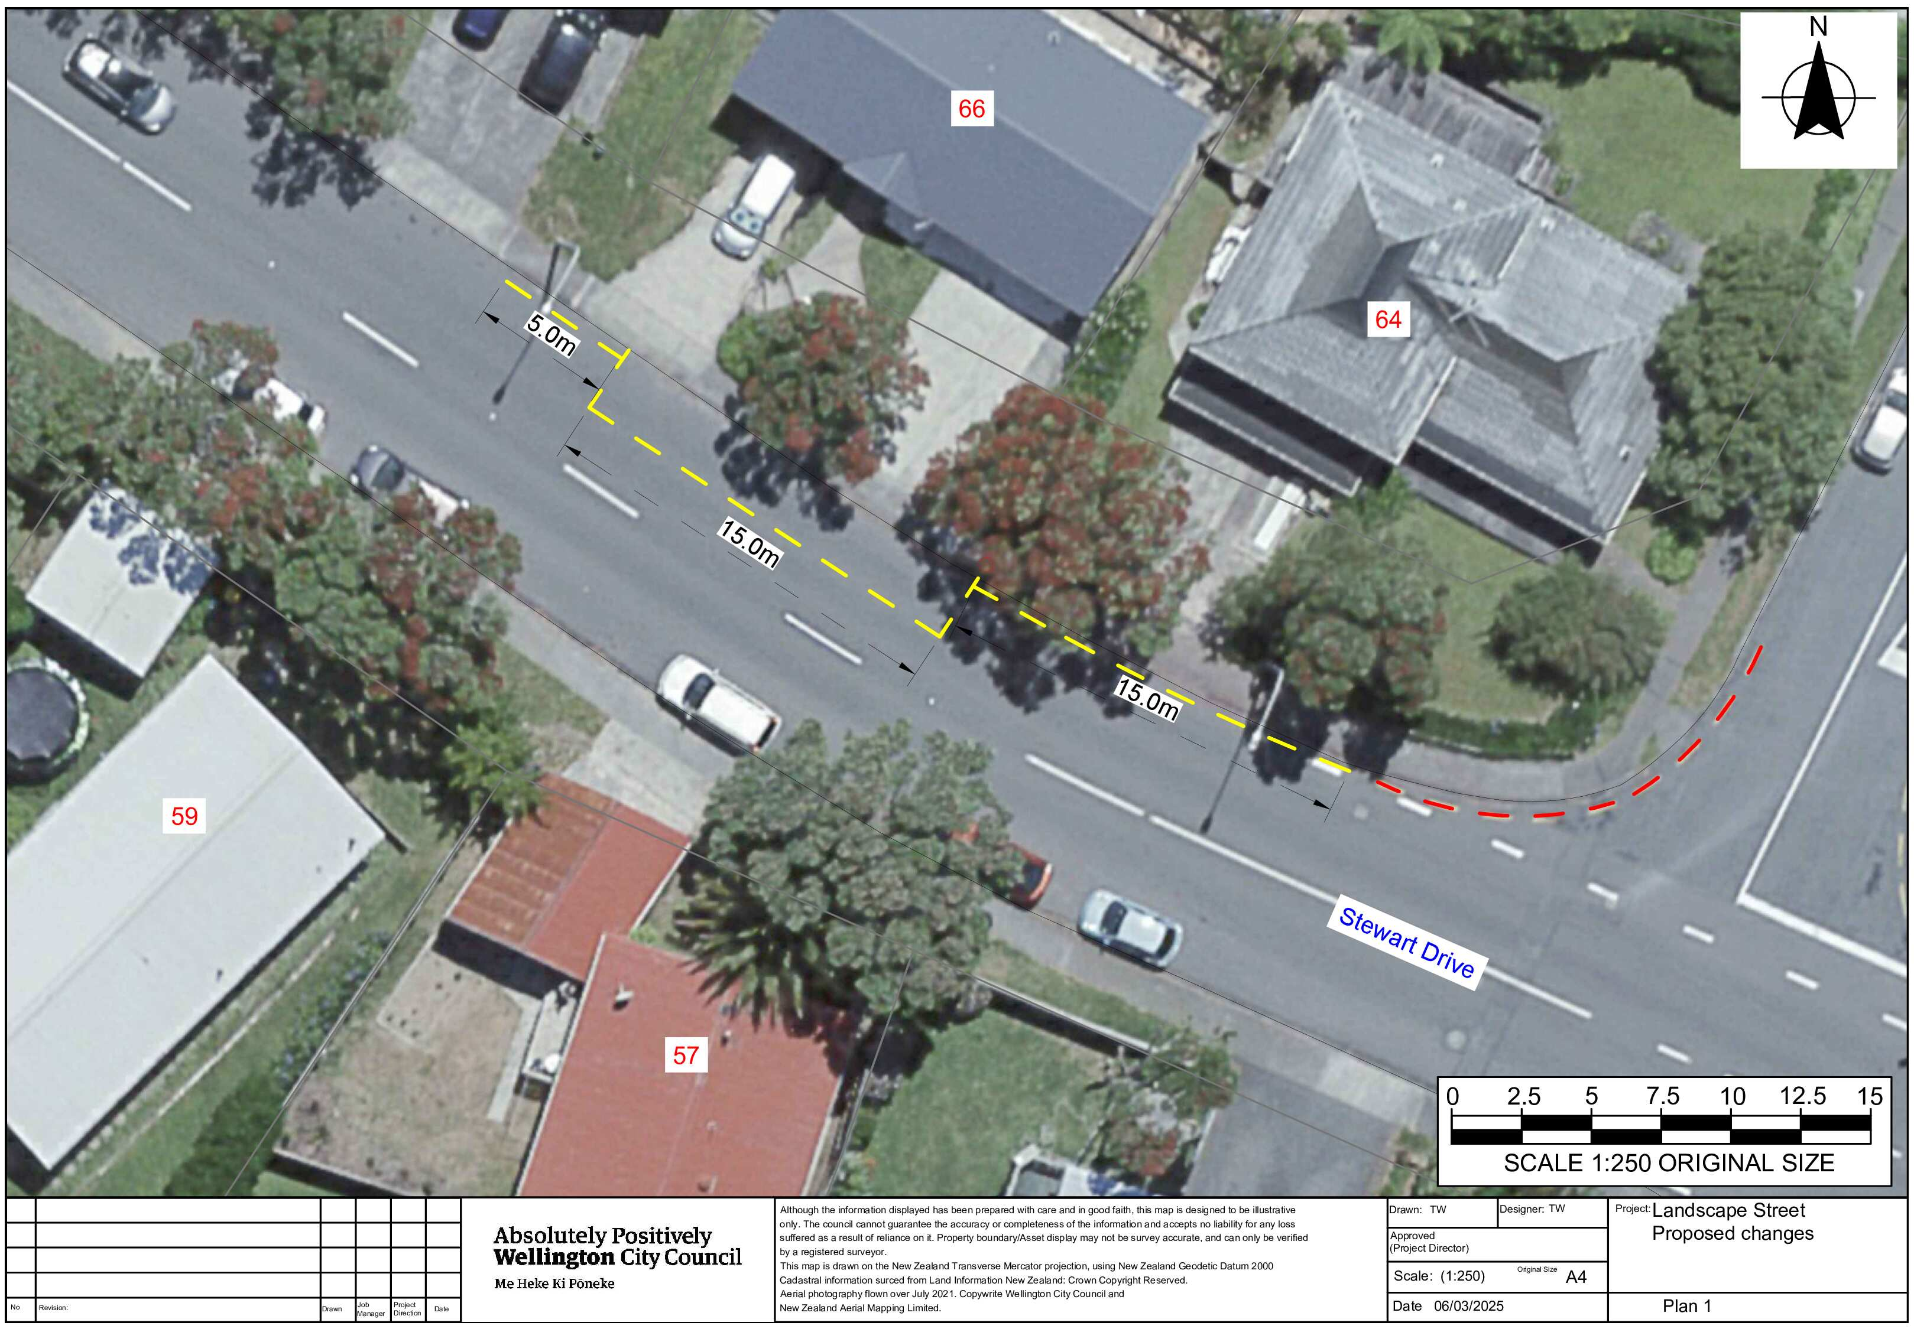
Traffic Resolution Plan: TR38-25 Stewart Drive, Newlands - Bus Stop Formalisation (#3404)

Legal Description:

Add to Schedule D (No Stopping) of the Traffic Restrictions Schedule

Column One | Column Two | Column Three
Stewart Drive | No Stopping At All Times | North side, commencing 9.5 metres west of its intersection with Padnell Crescent (Grid coordinates X=1,752,358.94m Y=5,435,063.59m) and extending in an westerly direction following the northern kerbline for 15 metres.
Stewart Drive | No Stopping At All Times | North side, commencing 39.5 metres west of its intersection with Padnell Crescent (Grid coordinates X=1,752,358.94m Y=5,435,063.59m) and extending in an westerly direction following the northern kerbline for 5 metres.

Add to Schedule B (Class Restricted) of the Traffic Restrictions Schedule

Column One | Column Two | Column Three
Stewart Drive | Bus Stop At All Times | North side, commencing 24.5 metres west of its intersection with Padnell Crescent (Grid coordinates X=1,752,358.94m Y=5,435,063.59m) and extending in an westerly direction following the northern kerbline for 15 metres.

Prepared By: | Tommy Wilson | (Transport Engineering Assistant)
Approved By: | Kate Gourdie | (Team Leader Traffic & Resolutions)
Approved Date: | 10/04/2025

