Kia ora,

We would like to inform you about a proposed change in your neighbourhood.

Proposal:

Reference | - TR38-26 Oxford Street, Tawa – Tawa Primary School Parking Changes
Location – where we propose to make the change | Oxford Street, Tawa – Between no.6 and no.8
What we’d like to do | - Install P5 Pick up and Drop off 8:30am-9:15am & 2:45pm-3:30pm during school days only.  - Install No stopping except pick up and drop off zone 8:30am-9:15am & 2:45pm-3:30pm during school days only.
Why we are proposing the change | - Council has received a request from Tawa Primary School regarding challenges parents and caregivers face during drop-off and pick-up times at the start and end of the school day.  - Council officers carried out multiple site inspections during morning and afternoon peak periods to observe public safety, traffic conditions and driver behaviour, in order to identify the most effective solution to reduce congestion and improve traffic flow while ensuring public safety is not compromised.  - The installation of two designated pick-up and drop-off restriction areas will allow parents and caregivers to stop closer to the school entrance, creating a safer and smoother drop-off and pick-up process.  - During site observations, officers noted that most vehicles parked in this area remained unattended for extended periods and were not actively involved in picking up or dropping off tamariki.  - The “No Stopping – Pick Up and Drop Off” restriction is intended for quick drop-offs and pick-ups without drivers leaving their vehicles and aided with the active Kea crossing supervised by school staff, while the P5 parking allows for longer vehicle stopping times.  - In addition, Council officers have received feedback from members of the public regarding insufficient mobility parking at this location and therefore propose to include an additional mobility parking space.  - Council officers presented this proposal ahead of public consultation to ensure the School is comfortable and in agreement with Council proceeding with the proposed plan and have shown their support for these parking changes.
Impact | Improvements  - Improves safety and accessibility for mobility park users  - Improves parking availability  Net Parking Impact  - Converting one P30 and three unrestricted spaces to four No Stopping except Pick up and drop off spaces, 8:30am-9:15am, 2:45pm-3:30pm School Days Only.  - Converting four unrestricted spaces to P5 pick up and drop off  - Converting one unrestricted space to Mobility parking at all times  Pedestrian impact  - No Change
Other options considered | Option 1:  - The other option officers have considered is to swap the locations of the pickup and drop off restrictions having the P5 outside no.6 and the no stopping except pickup and drop off outside no.8.
How this relates to the parking policy | - Support safe movement – facilitate the safe and efficient movement of people and goods by focusing on people moving along transport corridors rather than people parking or storing stationary vehicles.  - Support city place-making, amenity and safety – ensure on-street parking design and placement supports overall city amenity, safety, community building, heritage, creative arts, good urban design outcomes and attractive streetscapes.  - Support access for all – ensure disabled people, older people, people who are pregnant, and people with babies can access the city, Council facilities, and venues. This will be achieved, in part, through an improvement in mobility parking across the city.
Additional Information | - To view the legal description for this Traffic Resolution, an electronic copy of the report will be available on the Council’s website from 9.00am 15 April 2026 at https://www.letstalk.wellington.govt.nz/
Privacy | - Your privacy is important to us. Please DO NOT add specific personal details to your feedback (i.e.: full name, address, etc)  - What we do with your personal information:  All submissions (including your first name, but not contact details) are provided in their entirety to elected members and made available to the public on our website and at our office. Personal information (including contact details) will also be used for the administration of the consultation process including informing you of the outcome of the consultation. All information collected will be held by Wellington City Council, with submitters having the right to access and correct personal information.  - For more information regarding our Privacy Statement please check our webpage: Privacy statement - Wellington City Council.
Feedback | - If you would like to provide us with specific feedback, which will be added to the Traffic Resolution following consultation and made public in full, you can do so by filling out an online submission form, downloading a printable submission form on https://www.letstalk.wellington.govt.nz/ or emailing us at trfeedback@wcc.govt.nz.  Please note if you are giving feedback the consultation period opens at 9.00am 15 of April 2026 and finishes at 5.00 pm 30 of April 2026
Next Steps | - Feedback collated by 1 of May 2026.  - The proposal will go to the Te Takere|Regulatory Processes Committee meeting on 3 of June 2026.  - If approved, the proposal will be installed within the following six months.

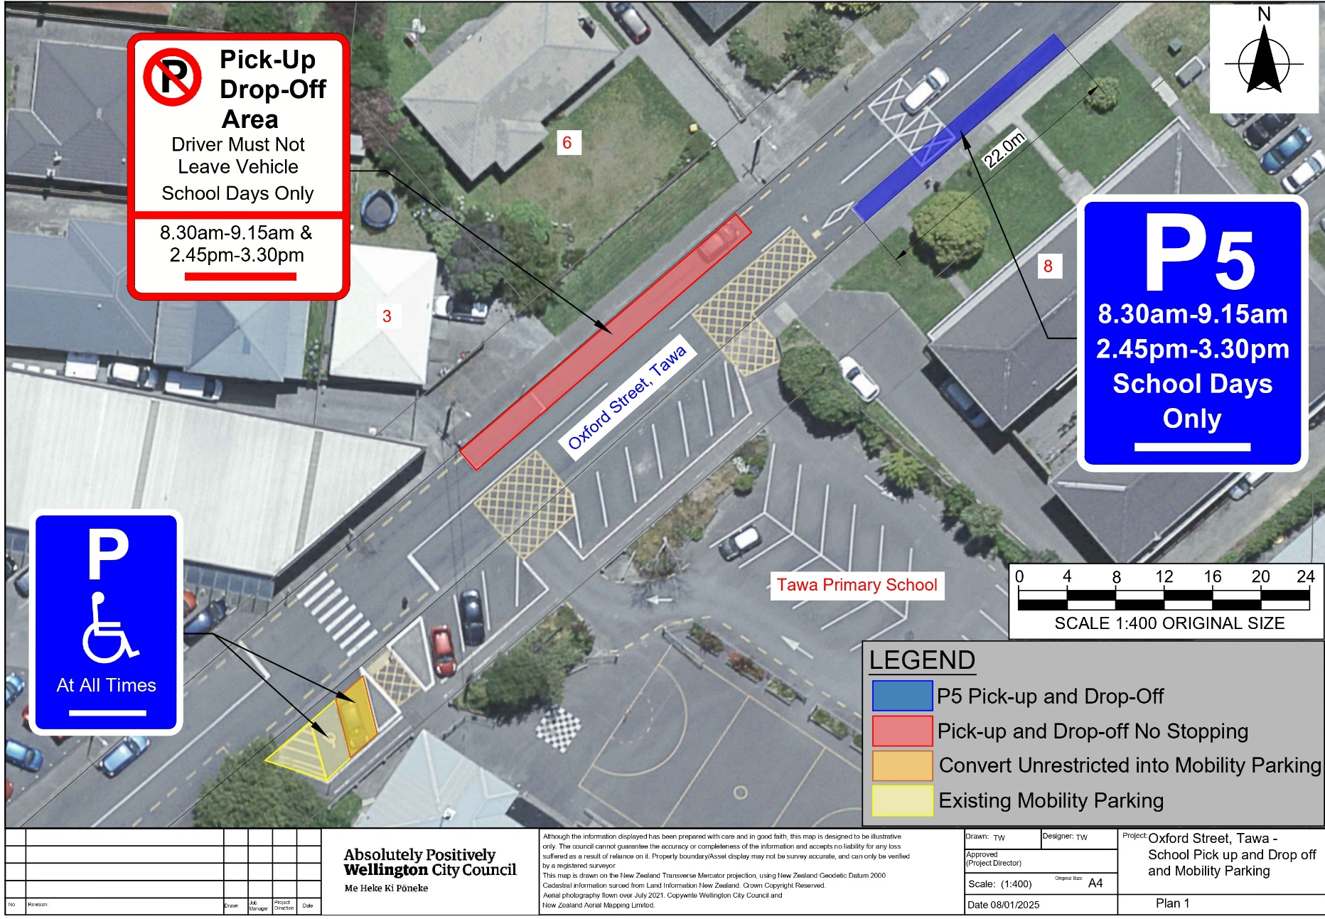
Traffic Resolution Plan: TR38-26 Oxford Street, Tawa – Tawa Primary School Parking Changes

Legal Description:

Delete from Schedule A (Time Limited) of the Traffic Restrictions Schedule

Column One | Column Two | Column Three
Oxford Street (Tawa) | P30 Saturday 9:00am – 12:00pm | North side, commencing 83 metres east of its intersection with Main Road (Grid coordinates x= 1753055.1 m, y= 5440375.9 m), and extending in an easterly direction following the northern kerbline for 10 metres.

Add to Schedule B (Class Restricted) of the Traffic Restrictions Schedule

Column One | Column Two | Column Three
Oxford Street (Tawa) | Mobility Parking Only At All Times | Southeast side, commencing 63 metres east of its intersection with Main Road (Grid coordinates x= 1,753.053.19m, y= 5,440.363.55m), and extending in a north easterly direction following the southeastern kerbline for 10 metres.

Add to Schedule A (Time Limited) of the Traffic Restrictions Schedule

Column One | Column Two | Column Three
Oxford Street (Tawa) | P5 Pick up and Drop off,  8.30am - 9.15am  2.45pm - 3.30pm, School Days Only | Southeast side, commencing 130 metres east of its intersection with Main Road (Grid coordinates x= 1,753.053.19m, y= 5,440.363.55m), and extending in a north easterly direction following the southeastern kerbline for 22 metres.

Add to Schedule D (No Stopping) of the Traffic Restrictions Schedule

Column One | Column Two | Column Three
Oxford Street (Tawa) | Pick-Up Drop-Off Area, Driver Must Not Leave Vehicle, School Days Only,  8.30am - 9.15am 2.45pm - 3.30pm, | Northwest side, commencing 79 metres east of its intersection with Main Road (Grid coordinates x= 1,753.057.07m, y= 5,440.382.23m), and extending in a north easterly direction following the northwestern kerbline for 30 metres.

Prepared By: | Tommy Wilson | (Transport Engineering Assistant)
Approved By: | Kate Gourdie | (Team Leader Traffic & Resolutions)
Approved Date: | 18/03/2026

