

Tāone tupu ora
Urban development
Background report
March 2026
Contents

Purpose 2
Council Activities 2
What we do as a council 3
Budget 5
Why is this activity important? 0
Current Direction 1
Direction from Legislation and National Regulations 1
Regional settings 2
Wellington City Council settings 3
Indicators and trends: Urban Development 4
Stakeholder views about Urban Development 8
Māori and Tākai Here partners’ views and aspirations for urban development 11
Key issues and opportunities 13
Lack of affordable housing for lower income residents 13
Infrastructure affordability and resilience challenges impact urban growth and regeneration 14
Responding to climate change as the risks and costs increase 15
Public perception of safety and vibrancy continues to decline 17
The Council’s building projects support urban regeneration 17
Ageing assets, rising costs, and funding limitations 18
Three waters and transport infrastructure 18
Integrating universal design into urban development 20
Inclusion requires a considered approach 20
Emergency management is improving, but has gaps for a sustained emergency response 21

Purpose
This background report provides a clear, evidence‑based overview of Wellington City Council’s Urban Development activity. It sets out what the Council does, why it does it, how it is funded, how it is performing, and the key issues shaping future choices.
The report is intended to support informed engagement with the Council’s role in urban development. It provides advisory groups with shared context on Council responsibilities, settings, constraints, and strategic direction, and supports elected members by bringing together relevant information, performance insights, stakeholder views, and emerging challenges to inform deliberations through the Long-term Plan (LTP) 2027–2037 process.
This is not a strategy or a set of recommendations. Rather, it is a foundation document that identifies current settings, pressures, and opportunities, and surfaces the key trade‑offs that will need to be considered as the Council refreshes its strategic direction and investment approach for urban development within a constrained fiscal environment.

Council Activities
A Council ‘activity’ is a formal Local Government Act 2002 (LGA 2002) term to refer to Council goods and services. Council activities are grouped for the purposes of the Long-term Plan and budgets – some are relatively stand-alone like transport. This group of activities includes:

6.1 Urban Planning, heritage and public spaces development
6.1.1 Urban Planning and policy development
6.1.2 Public spaces and centres development
6.1.3 Built heritage development
6.1.4 Housing development
6.2 Building and development
6.2.1 Building Control and Facilitation
6.2.2 Development Control and Facilitation
6.2.3 Earthquake risk and mitigation
6.2.4 Regulatory Building Control and Facilitation (weathertight homes)

What we do as a council
The Council’s urban development functions are broad, from strategic planning to regulation to delivering and facilitating development projects. They include:

- Strategic Planning and Regulation
- Setting direction and rules for development, identifying areas for growth or change, and planning the infrastructure needed to support housing and economic activity.
- Developing urban development frameworks and strategies to attract and sustain investment in Wellington’s future.
- Issuing resource and building consents in line with the District Plan and evolving national legislation.
- Conducting research and analysis on urban development trends and future scenarios.
- Aligning with central and regional government requirements and incorporating public feedback into planning processes.
- Urban Regeneration and Infrastructure Delivery
- Upgrading suburban centres, road corridors, pedestrian areas, city parks, and laneways.
- Delivering urban improvement projects, such as Te Ngākau Civic Precinct and the Green Network Plan.
- Facilitating major development projects, including Shelly Bay, Lyall Bay, and Matai Moana.
- Leasing and partnering on developments (e.g., Te Kāinga affordable apartment rentals, Michael Fowler Centre car park commercial development).
- Managing surplus Council land sales and targeted redevelopments (e.g., St Johns site in Karori, old Johnsonville Library site).
- Asset and Building Management
- Managing Council building acquisition, maintenance, construction/strengthening, and disposal.
- Owning and upgrading 1,900 social housing units through Te Toi Mahana (community housing provider).
- Overseeing the earthquake-prone building programme and administering relevant regulations.
- Design, Heritage, and Environmental Leadership
- Providing design and heritage advice for public and private projects.
- Reducing the Council’s carbon emissions and supporting broader city de-carbonisation initiatives.
- Long-term climate adaptation planning and advice.
- Partnerships and Emergency Preparedness
- Liaising with Wellington Water and the future Tiaki Wai Metro Water entity to ensure integrated water management.
- Preparing for emergencies, from local incidents to large-scale hazard events.

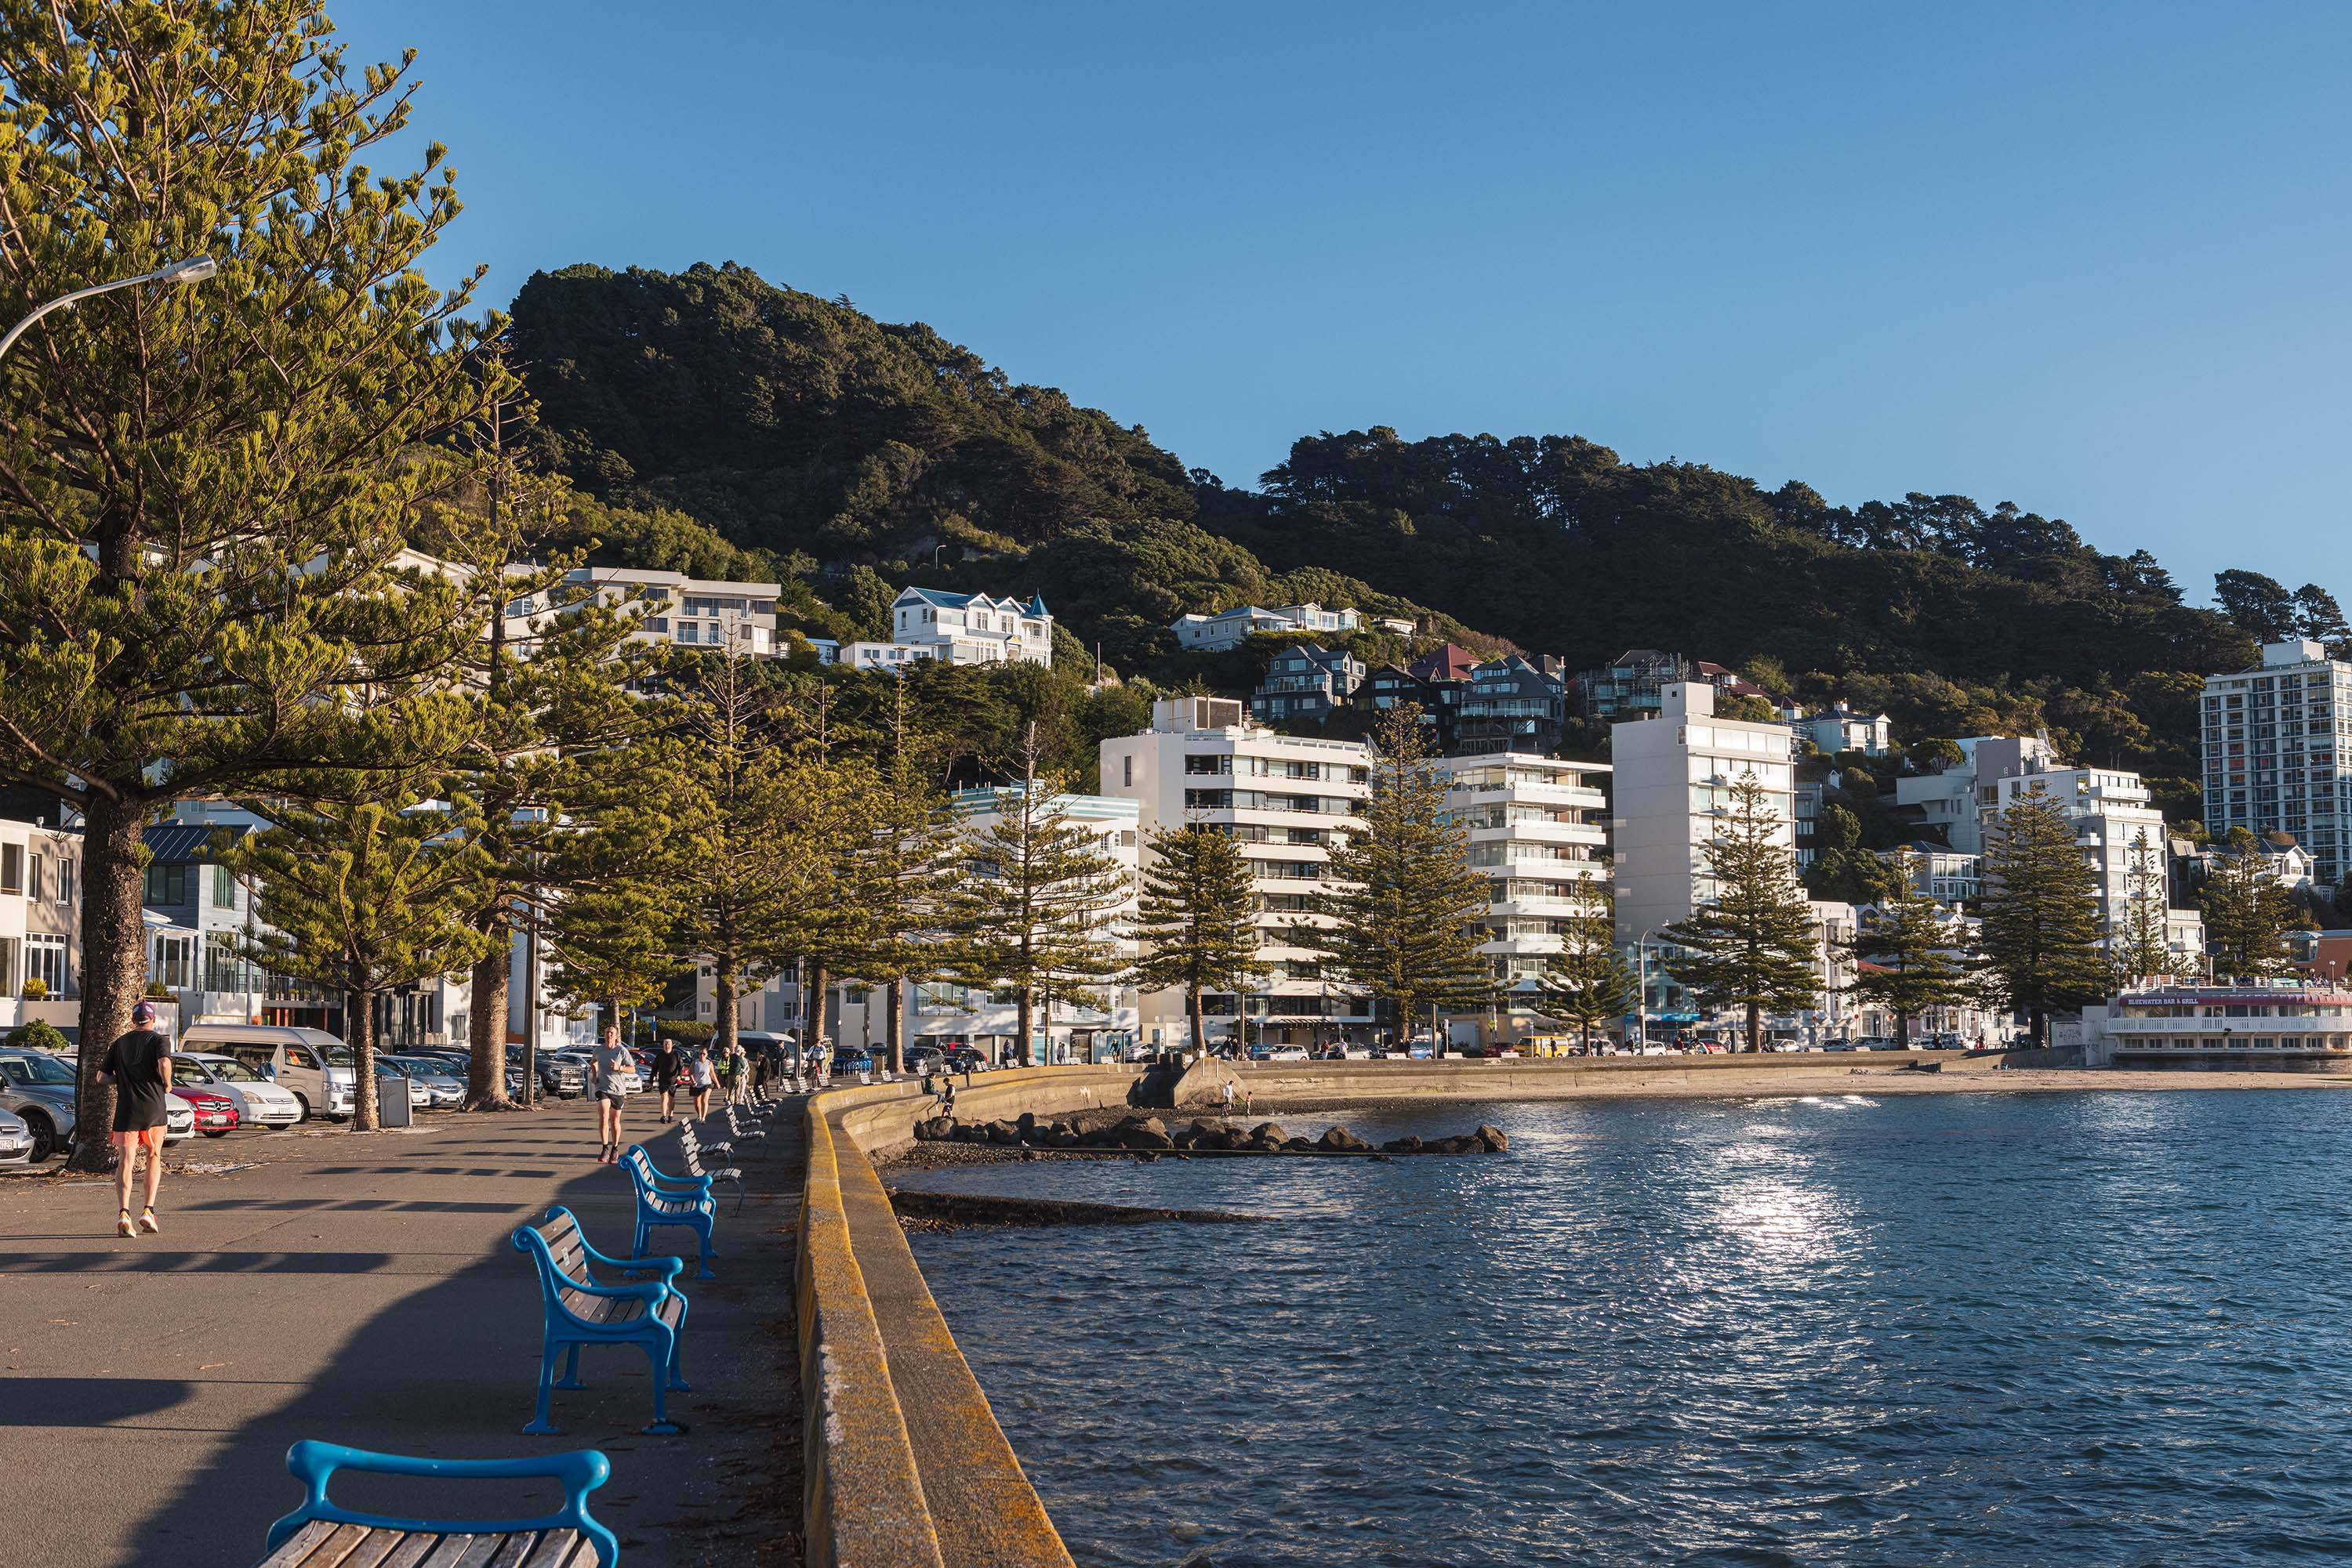

Budget
You can find more information in the LTP 2024 Amendment.
Percentage of total council spend:
Opex – 8.7%
Capex – 8.1%

Operating Expenditure
Activity Component Name | Income/  Expense | 2024/25 | 2025/26 | 2026/27 | 2027/28 | 2028/29 | 2029/30 | 2030/31 | 2031/32 | 2032/33 | 2033/34
6.1.1 Urban planning and policy development | Expense | 6,958 | 7,013 | 6,584 | 6,536 | 6,370 | 6,207 | 6,281 | 6,389 | 6,497 | 6,664
6.1.1 Urban planning and policy development | Income | (1,980) | (924) | (595) | (608) | (620) | (633) | (645) | (657) | (670) | (682)
6.1.2 Public spaces and centres development | Expense | 13,210 | 24,274 | 27,752 | 7,038 | 7,733 | 8,319 | 8,285 | 8,391 | 8,443 | 8,808
6.1.3 Built heritage development | Expense | 1,255 | 1,527 | 1,552 | 1,577 | 1,596 | 1,629 | 1,653 | 1,677 | 1,697 | 1,730
6.1.4 Housing Development | Expense | 16,044 | 16,873 | 18,222 | 18,680 | 19,044 | 19,504 | 20,016 | 20,813 | 21,170 | 21,786
6.1.4 Housing Development | Income | (13,277) | (13,666) | (15,572) | (16,057) | (16,532) | (17,028) | (17,512) | (18,082) | (18,608) | (19,118)
Total |  | 22,210 | 35,097 | 37,943 | 17,167 | 17,590 | 17,999 | 18,078 | 18,532 | 18,530 | 19,188

Activity Component Name | Income/  Expense | 2024/25 | 2025/26 | 2026/27 | 2027/28 | 2028/29 | 2029/30 | 2030/31 | 2031/32 | 2032/33 | 2033/34
6.2.1 Building Control and Facilitation | Expense | 22,896 | 24,022 | 24,199 | 24,755 | 25,177 | 25,905 | 26,457 | 26,995 | 27,424 | 28,090
6.2.1 Building Control and Facilitation | Income | (16,181) | (16,520) | (16,884) | (17,239) | (17,584) | (17,919) | (18,259) | (18,606) | (18,942) | (19,283)
6.2.2 Development Control and Facilitation | Expense | 9,223 | 12,923 | 12,617 | 12,876 | 13,038 | 13,375 | 13,648 | 13,966 | 14,228 | 14,612
6.2.2 Development Control and Facilitation | Income | (5,749) | (5,864) | (5,993) | (6,124) | (6,253) | (6,378) | (6,499) | (6,623) | (6,749) | (6,870)
6.2.3 Earthquake risk mitigation – built environment | Expense | 4,810 | 2,090 | 1,729 | 1,767 | 1,798 | 1,850 | 1,889 | 1,928 | 1,961 | 2,013
6.2.3 Earthquake risk mitigation – built environment | Income | (3) | (3) | (3) | (3) | (3) | (4) | (4) | (4) | (4) | (4)
Total |  | 14,996 | 16,647 | 15,665 | 16,032 | 16,173 | 16,830 | 17,232 | 17,657 | 17,920 | 18,558

Capital Expenditure
Activity Component Name | 2024/25 Published budget | 2024/25 Amendment budget | 2025/26 | 2026/27 | 2027/28 | 2028/29 | 2029/30 | 2030/31 | 2031/32 | 2032/33 | 2033/34
6.1.1 Urban planning and policy development | 1,544 | 776 | 993 | 0 | 0 | 0 | 0 | 0 | 0 | 0 | 0
6.1.2 Public spaces and centres development | 2,936 | 1,285 | 7,851 | 1,667 | 6,630 | 714 | 1,121 | 967 | 2,427 | 5,918 | 2,516
Total | 4,480 | 2,060 | 8,845 | 1,667 | 6,630 | 714 | 1,121 | 967 | 2,427 | 5,918 | 2,516

Activity Component Name | 2024/25 Published budget | 2024/25 Amendment budget | 2025/26 | 2026/27 | 2027/28 | 2028/29 | 2029/30 | 2030/31 | 2031/32 | 2032/33 | 2033/34
6.2.3 Earthquake risk mitigation – built environment | 57,852 | 57,815 | 54,389 | 0 | 0 | 0 | 0 | 0 | 0 | 0 | 0
Total | 57,852 | 57,815 | 54,389 | 0 | 0 | 0 | 0 | 0 | 0 | 0 | 0

Urban Development Funding Sources
Urban Development Subactivity | User Fees | Rates Contribution*
Urban Planning & Policy development | 0%-10% | 90-100%
Public Spaces and centres development | 0% | 100%
Built heritage development | 0% | 100%
Housing Development | 0% | 100%
Building Control and Facilitation | 60-70% | 30-40%
Development Control and Facilitation | 40-50% | 50-60%
Earthquake risk mitigation – built environment | 0% | 100%
Regulatory Building Control and Facilitation (weather tight homes) | 0% | 100%
*General rates. Source: 2024 LTP Volume 2

Why is this activity important?
Urban development is about shaping a liveable, connected and sustainable city. The Council’s city growth strategies and investments are underpinned by up-to-date evidence, national and regional policy and stakeholder feedback.

Residents have voiced strong support for a city growth approach that makes the city more compact, accessible, and resilient. There is broad consensus on the need for more housing supply (to improve affordability) but in a way that is well-supported by transport, infrastructure, community facilities, and that responds to challenges like climate change.

The Spatial Plan, updated for 2025-26, is the Council’s strategy to achieve this balance. It prioritises directing growth into areas with good public transport, existing services and infrastructure capacity, and where development can enhance urban liveability, as opposed to sprawling development with car-dependent greenfield areas. By concentrating development in the right places, the plan helps create well-connected neighbourhoods and protects the environment and character values that Wellingtonians cherish. Equally, it allows the Council to coordinate investments (roads, pipes, parks, safe walking and cycling
networks etc.) more efficiently to support this growth.

Central government directives have significantly influenced the Spatial Plan. Recent central government initiatives, such as on housing growth have informed the plan’s direction, and proposed new funding tools for infrastructure (e.g. urban growth partnerships, and updated developer levies) provide context for how councils plan to support and fund urban development. Recent changes in the transport policy environment have also required the Council to recalibrate how major transit and roading projects will be factored into growth plans.

At the regional level, the Wairarapa–Wellington–Horowhenua Future Development Strategy 2024 provides reinforcement that the bulk of new housing and jobs should be accommodated within existing urban areas well-served by transit, to support a low-carbon, well-connected region.

A strengthened evidence base underpins the Council’s approach to planning: for example, updated population and housing projections (using 2023 Census data) and the latest Housing and Business Capacity Assessment have been used to gauge future growth. These studies show that under the 2024 District Plan settings Wellington has capacity for on the order of 39,000+ additional dwellings (subject to market feasibility). Technical analysis has been commissioned by the Council to pinpoint where and when development is likely to occur and to identify infrastructure constraints. Updated three-waters network capacity studies and transport analyses also highlight which areas can support more housing and which will require upgrades. This internal evidence-gathering process ensures that the Council’s urban development planning is grounded in realistic growth trends and infrastructure needs as well as stakeholder views.

Current Direction

Direction from Legislation and National Regulations
Managing urban development is a significant purpose and role of local government. However, the Council’s urban development programmes are influenced and filtered by central government legislation and national direction. These set some things the Council must do, can do, and must not do. Policy and direction at a regional level can also direct the Council’s policy and actions. The Council can have urban development activities separate from this direction, as long as it fits within the purpose of local government. The Council’s affordable apartment programme Te Kainga is an example of this.
Some important changes to legislation are noted below.

The Building Act and the Resource Management Act (RMA) and its regulations set the Council’s role as a consent authority for buildings, land uses and subdivision. They set some nationally consistent regulations (for example life safety building standards), and policy directions (for example, buildings at least six stories to be enabled around rapid transit stations). The government is proposing significant changes to the Building Act, and replacing the RMA with new Acts. These changes will affect the Council’s current regulatory functions, and how it works with other councils in the region.

The Council has new functions for water services under the Local Government (Water Services) Act 2025, and for some large-scale infrastructure and development projects under the Fast Track Approvals Act. For both, the Council is no longer the decision-maker and operator but still can influence and give high-level directions at set stages.

The government also proposes to replace the Civil Defence Emergency Management Act with a new Act. The new Act will expand the Council’s tools and powers for emergency management, including into urban intensification, infrastructure and planning.

The Local Government (Systems Improvement) Amendment Bill proposes to remove social, economic, environmental and cultural wellbeing (the four wellbeings) from the purpose of the Local Government Act 2002 (LGA 2002 section 10 refers) and refocus the purpose on core infrastructure and services.

These core services will include local infrastructure, public services and regulatory functions, which support local economic growth and development. The functions directed by government for urban development (for example, roads and land use planning) will remain the same. Subject to final amendments to the LGA 2002, the role of the Council in delivering some of the other functions for urban development may need to be assessed – this would be an incremental process, as any changes to services or levels of service would remain subject to LTP and other democratic decision-making processes.

The Planning Bill and Natural Environment Bill were introduced to Parliament in December 2025 and went through first reading. The Bills are due to report back from Select Committee on 26 June 2026. The Bills will ultimately lead to the repeal of the Resource Management Act. Officers will be assessing what the Bills mean and drafting submissions for Council consideration.

Regional settings
The Council’s urban development roles are increasingly coordinated across the councils in the Wellington region and through a Wellington Regional Leadership Committee. Key regional documents are noted below.

The Wellington Regional Policy Statement is an RMA document by Greater Wellington City Council. It sets policies and methods that Wellington City Council needs to follow or implement, for example requiring new and altered land transport infrastructure to maximise the opportunity for people to shift to public transport and active modes. The government is proposing to integrate this document into a combined regulatory plan in its RMA reform.
A new Wellington Region Emergency Management Group Strategy and Plan is under development. These focus on overall community resilience and partner collaboration, not just reacting to emergency events.

The Wairarapa-Wellington-Horowhenua Future Development Strategy coordinates urban development actions over a 30-year timeframe across ten councils and their iwi partners. The Council must have regard to this Strategy and use it to inform land use and transport planning. The government is proposing to replace the Future Development Strategy with a new Regional Spatial Plan.

The councils in the region are preparing a Climate Change Regional Adaptation Project to respond to the government’s recently released national adaptation plan.

Wellington City Council settings
The Council has strategic documents and policy directions set by previous Councils. Officers continue to apply these until they are changed by a new Council or by regional/national direction. Key council plans and strategies applicable to the Urban Development activity area are the Long-term Plan (LTP) 2024-2034, Wellington City District Plan 2024, Wellington City Spatial Plan 2021, Economic Wellbeing Strategy 2022 and Te Atakura – First to Zero.
The Wellington City Spatial Plan 2021 is a strategic document that guides how the city grows, develops, and changes over the next 30 years, including how land use, transport and other infrastructure should be integrated and prioritised. The guiding objectives for the plan are:
- Compact: Creating a compact, liveable, easily accessible, and connected urban form that makes efficient use of existing infrastructure, community facilities, and transport links.
- Resilient: Building resilience to natural hazards and climate change and supporting sustainability in all aspects of city development.
- Vibrant and Prosperous: Supporting economic growth, creativity, and a vibrant city life.
- Inclusive and Connected: Enabling diverse, inclusive, and well-connected neighbourhoods and communities.
- Greener: Enhancing and protecting the city’s natural environment, promoting sustainability, and supporting Wellington’s transition to a zero-carbon future.

Te Atakura is the climate action plan to make Wellington City a zero-carbon capital (net zero emissions) by 2050 and includes the action area “Climate resilient urban form: The Council is the planning authority, enabling a compact urban form and increased resilience through District Plan settings and city design.”

Other relevant Wellington City Council strategic documents include the:
- Financial and Infrastructure Strategy 2024-2034
- Tūpiki Ora Māori Strategy 2022
- 30-year Infrastructure Strategy 2024
- Wellington Housing Strategy 2018 and Action Plan 2023-2025
- Heritage Policy 2010
- Open Space and Recreation Strategy 2023

Other Council policies are linked on the Council website.

Indicators and trends: Urban Development

The Council owns, and sources from other agencies, lots of data and models on Wellington City’s urban development. Some indicators and trends are summarised below.

Slow and steady population growth affected by COVID, and household changes
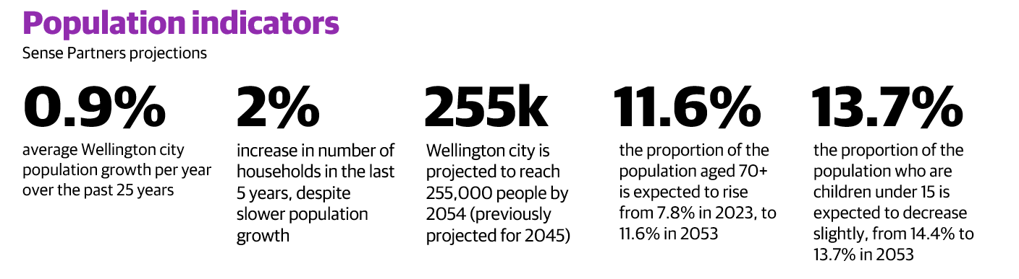
Wellington City has experienced slow and steady population growth over the past decades, although COVID-19 and economic migration led to a small population dip in the last five years. While over the same period there was a rise in one and two person households, indicating a need for more homes despite lower overall population increases. Looking ahead, demographic projections indicate an ageing population and a slight decline in the proportion of children, with growth now expected to lag behind both regional and historical rates.

Fewer children in suburbs without new housing
From 2018 to 2023, Wellington City had a 19% drop in 0-4 year olds and 15% drop in 5-9 year olds. This may affect primary school services in some areas, especially in suburbs where new housing developments do not occur to stabilise school rolls. Countering the overall trend, new housing in the City Centre (and changes in household types) has resulted in a 39% increase in 5-15 year olds over this time. Outer suburbs where new housing was built such as Churton Park and Newlands also had more children.

Construction rates rose then dropped
Building rates are strongly influenced by real estate and construction prices and the cost of borrowing. The current combination of lower house sale prices and higher building construction prices (especially for apartments) is limiting development opportunities. The number of new homes built in the Wellington Region hit a peak in 2021-2022 – the highest since the mid-1970s. Since then, the rate of building has dropped off. Wellington City in particular is currently experiencing the lowest number of new dwelling consents since at least the 1980s.
Number of new homes consented per year (1yr rolling avg)

The Hutt’s district plan changes, which came into force in 2019, enabled medium density housing and saw resulting growth in new residential consents (as compared to Wellington, which saw a decline). Wellington’s plan changes occurred in late 2024, and we see early indications of growth in 2025 (as compared to the Hutt, which remains stable).

While building rates are very low in Wellington City at the moment compared to other large cities in New Zealand, they tend to be more complex and on average higher value than other councils in the region. Housing construction elsewhere in the region is supported in part by more greenfield land supply and a stronger first homeowner market.

Housing remains expensive
In 2025, Wellington City average dwelling values are 5.8x the average household’s gross income, compared to 4.7x in 2005. Two-fifths of renting households spent over 30% of their income on rent in 2018. Rental price increases have closely followed household income. These price-to-income ratios are similar to the Wellington Region because of higher average household income in Wellington City.

Housing development capacity fluctuates with economic conditions
Approximately 40,000 new homes are commercially feasible to be built in Wellington City as of July 2024. This is not the same as how many will be built. The number fluctuates a lot based on factors like interest rates, property prices and construction costs. For example, at the peak of the market in 2021 with the new District Plan controls, the estimate was 127,000 new homes. In the Wellington-Wairarapa-Horowhenua area there are around 200,000 new houses commercially feasible (estimated in 2023).

The new 2024 District Plan allows many more development options, especially in the suburbs closer to the City Centre which had tougher land use controls in the former district plan. This is illustrated by the District Plan-enabled heights in the map below.
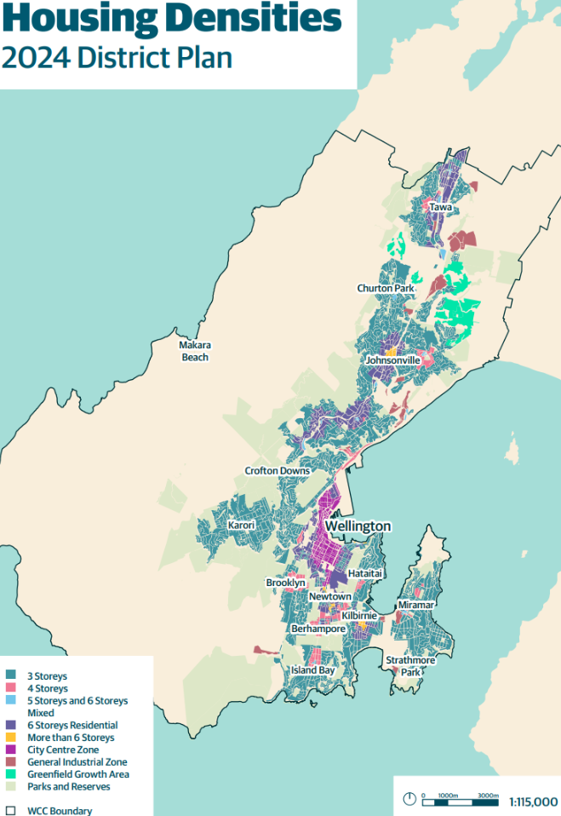
Changing location of work
Wellington City Centre remains the main employment centre for the region with over 40,000 jobs. The Newtown Hospital area a major secondary employment hub. A quarter to a third of people are working from home some or all of the time.

Changing demand for office space
Wellington City’s CBD office overall vacancy rate (13.4% in July 2025) is comparable to other New Zealand/Australian cities. Office space demand is moving north towards the Wellington Rail Station and to higher quality buildings. Wellington City has many ‘B’ and ‘C’ grade office buildings with high office vacancies at 24 percent (CBRE estimate), compared to ‘A’ grade buildings at 6 percent. ‘Premium’ grade offices (only a few of these) have essentially no vacancies. Some of the secondary ‘B’ and ‘C’ grade buildings are being converted into apartments, social housing and student housing.

Fewer earthquake-prone buildings, but some strengthening still needed
The number of buildings in Wellington City classified as earthquake prone on the register and needing strengthening is likely to be halved to around 270 buildings under the government’s new earthquake-prone buildings policy. For some still on the register, the strengthening work can be focused on parts affecting public safety. Some of these buildings will still choose to strengthen and retrofit to meet the expectations of residents, businesses, the public, and to maintain their market value.

Stakeholder views about Urban Development
The community and organisations shared their views on urban development in recent consultations on the draft Long-term Plan (2023), Draft District Plan (2021) and Proposed District Plan (2022), the Spatial Plan (2020), the Residents Climate Action Monitor Survey (2024), and the Residents Monitoring Survey (2025). The draft Spatial Plan received almost 3,000 submissions, on top of the 1,400 submissions on the Planning for Growth scenarios and tens of thousands of people engaging with videos and social media. These views, as well as feedback from the Council’s Advisory Groups, are summarised below.

General support for city growth to be mostly within existing areas, but with local input to planning
- In the Growth Scenarios Engagement 2019, most respondents preferred an overall urban growth approach focused on the inner city and suburban centres. Only a quarter of respondents agreed with building new greenfield suburbs in rural areas.
- Some submitters wanted more localised planning or community-led design processes.
- General support for actions to make Wellington a vibrant, liveable city. Residents saying Wellington has a positive look and feel decreased from around 80% pre-COVID to 45% in 2025.
- Advisory Groups have consistently called for early and meaningful engagement in urban planning, not just feedback at the project stage. They emphasise that advice informed by diverse identities should shape strategic direction from the outset, and that local voices, including those of underrepresented communities, must be included in planning processes
- The Pacific Advisory Group (PAG) and Ethnic Communities Advisory Group (ECAG) have highlighted the need for consultation that is explicit about naming communities and ensuring that definitions and priorities are co-designed with those affected.

The Spatial Plan and District Plan consultation supported more housing but disagreement on where and how to enable it
- There is an understanding that the city will grow but people want infrastructure to support growth, and for housing to be warm and affordable.
- Community groups, individuals and submitters gave many different views either supporting or opposing high density development to be enabled within walking distance of railway stations, or the City Centre Zone, or in Johnsonville and Kilbirnie. There was also a wide range of views supporting and opposing both increasing and decreasing character precinct controls.
- General support for options to require new development to include affordable housing, and for increasing housing supply for more affordable housing options.
- The Youth Advisory Group and ECAG have noted that affordable, accessible housing is a top priority, but that the location and type of new housing must reflect the needs of diverse communities, including multi-generational families (PAG) and young people (RYCAG).
- Advisory Groups have also stressed the importance of infrastructure and services keeping pace with growth, and that community-led design processes can help resolve disagreements about density and location.

Support for development that improves amenity and wellbeing, and enhances parks and natural areas
- People seek city surroundings that are pleasant and inviting, and that enhance their experience of living, working, and playing there. Some wanted more green and open spaces for residents.
- People support city regeneration and want attractive buildings and surrounds, utilised (e.g., not vacant or run-down), and appealing. This also applies to open spaces like the waterfront.
- Balancing growth and change in amenity values – some sought built form standards be amended to decrease building height and density and add setback, particularly between high- and low-density areas.
- Accessibility needs of different people are important when planning public spaces.
- General support for wildlife and biodiversity protection, but with opposition to the regulatory protection of areas of native vegetation on private land, especially residential areas. Instead, there is support for community-based restoration of biodiversity.
- Accessibility Advisory Group (AAG) and Takatāpui Rainbow Communities Advisory Group (TRCAG) have advocated for public spaces that are safe, inclusive, and accessible for all, with a strong emphasis on universal design and the need for green, open spaces that support wellbeing.
- The Pacific Advisory Group has raised the risk of displacement due to gentrification and the need for parks and amenities that support multi-generational and culturally diverse families.

Investment in infrastructure
- Concerns that existing infrastructure may not handle projected growth, and a desire for upgrades, particularly three waters and transport infrastructure.
- There was strong support for increased investment in water infrastructure, with many submitters prioritising fixing leaking pipes over other projects.
- Advisory Groups, especially the Youth Council and AAG, have called for strategic investment in infrastructure—not just to support growth, but to address persistent barriers to inclusion and accessibility. They stress that upgrades to water, transport, and community facilities must be planned with input from those most affected, and that accessibility should be embedded in all new projects.
- There is strong support for increased investment in water infrastructure and for prioritizing repairs and upgrades that benefit vulnerable and lower-income residents.

Support for integration of te ao Māori
- There is support for te ao Māori to be acknowledged in the Council’s projects.
- Support the recognition and acknowledgement of mana whenua values and roles.
- Advisory Groups, especially through the Combined Strategic Advisory Panel, have emphasised the need for genuine partnership with mana whenua and the integration of te ao Māori in all aspects of urban development. This includes co-design, visibility of te reo and Māori culture, and support for Māori-led housing and urban initiatives.

Support in principle for reducing emissions and increasing resilience, but not necessarily support for specific and effective actions
- From the Climate Action Monitor 2025:
  - 85% believe people need to act to reduce Wellington’s carbon emissions
  - 86% believe the negative effects of climate change are already impacting Wellington
  - 54% feel confident enough action is being taken to reduce carbon emissions
  - 44% feel confident enough action is being taken to prepare Wellington for the impacts of climate change
- There is broad support for sustainable initiatives, such as a fund to encourage sustainable buildings and carbon-zero transport options, but people are reluctant to bear the costs of these initiatives.
- Advisory Groups support climate action and resilience, but stress that initiatives must be affordable and accessible for all. There is broad support for sustainable buildings and carbon-zero transport, but concern about the costs falling disproportionately on vulnerable communities.

Land use – transport alignment
- Calls for better alignment between land use and transport planning.
- General support for improvements to public transport services and alternative transport modes.
- Advisory Groups have repeatedly called for better alignment between land use and transport planning, with a focus on public and active transport that is accessible, safe, and affordable for all ages and abilities.
- The AAG, in particular, has emphasised the need for systemic solutions, not just ad-hoc upgrades, to ensure that transport networks support the mobility and participation of disabled and older residents.



Māori and Tākai Here partners’ views and aspirations for urban development
The Tākai Here partners have a shared aspiration to meet the social, economic and cultural needs of their communities. Within their individual entity strategies, they each identify a responsibility to improve housing and urban development opportunities that are accessible, affordable and equitable.

Existing and emerging urban development initiatives and programmes with the Council and Tākai Here partners include:
- Package of redevelopment projects that support mana whenua housing aspirations
- Creating housing solutions for mana whenua and Māori
- Contributing to broader housing projects and priorities
- Collaboration with central government agencies and housing providers

Mana whenua representatives shared their values and aspirations for urban development and city management more generally in the Te Tirohanga Whakamua statement prepared for the Wellington-Wairarapa-Horowhenua Future Development Strategy 2024.

Other mana whenua feedback has come from engagement on the Council’s Tūpiki Ora Māori Strategy 2022, preparation of the Proposed District Plan in 2022, the Ngāti Toa Housing Strategy 2021, and consultation on specific projects.

Action areas in urban development from the Tūpiki Ora Māori Strategy (developed in consultation with our mana whenua partners) include: combating homelessness; supporting whānau Māori into their own homes; providing more options to access social services such as mental health for rangatahi Māori; increasing opportunities to grow Māori businesses, leaders and entrepreneurs; and investing in greater representation and presence of mana whenua and Māori culture, language and identity within and across the city.

In a review of Council information on feedback from Māori on various projects, consistent messages on urban development included:
- Māori value cultural belonging and community. Māori stakeholders generally support urban development that is climate-resilient, inclusive, and reflective of Te ao Māori (Māori world) and taha Māori (Māori perspective) alongside recognition of all ethnic groups.
- They have concerns that the visibility of Māori culture and te reo Māori in city planning is not always sufficient.
- There is a strong expectation and desire for early, genuine engagement and shared decision-making or co-design, especially on housing, culturally significant precincts and venues, and central city redevelopment.
- There are capacity concerns for Tākai Here partners to participate effectively in Council processes.

Key issues and opportunities
The following section summarises issues and opportunities relating to the Council’s functions, responsibilities and interests in urban development.

Lack of affordable housing for lower income residents
Since 2022, first home buyers are benefitting from recent drops in house prices, and rental prices have stabilised. However, housing supply and affordability to buy and rent for those on lower incomes (including single income earners, retirees, students, and service workers) remains an ongoing challenge for Wellington City. The lack of affordable housing constrains social and economic opportunities and makes it harder to attract and retain workers. This affects workforce stability and local businesses. Community concerns persist about older homes affected by dampness and mould, which harms people’s health and wellbeing.

The public housing waitlist in Wellington City increased from 132 in March 2016, to a peak of 886 in March 2022 and currently sits at 684 applicants. Homelessness is also rising. The Downtown Community Ministry reports a 40% increase in September 2024 to 464 people. This housing instability worsens health and education outcomes and strains public services.

While these challenges remain significant, there are also notable opportunities for the Council to address urban development concerns and improve outcomes for the community.

The Council has a regularly reviewed housing strategy and action plan that connects planning, delivery, and partnerships. Recent actions include:
- The new Wellington City District Plan enables more housing to be built in areas with good access to jobs, services and transport. Government planning and building reforms are expected to enable more homes to be built. Council case management is helping housing developers navigate resource and building consent processes.
- The Te Kāinga programme is successfully converting ‘B’ and ‘C’ grade commercial buildings into more affordable residential apartments. However, lower rental prices are placing pressure on the programme.
- Some ‘deemed surplus’ Council land has been sold and is being redeveloped, with over 100 new homes planned across three sites.

The number of community housing provider developments are slowly increasing. Collaboration with iwi authorities and hapori Māori is ongoing, to understand housing aspirations and connect them to development discussions. Māori stakeholders have emphasised the importance of housing to meet the needs of whānau and early engagement in the planning process. The Council supports Māori housing projects and initiatives like those by Te Āhuru Mōwai (Ngāti Toa Community Housing Provider).

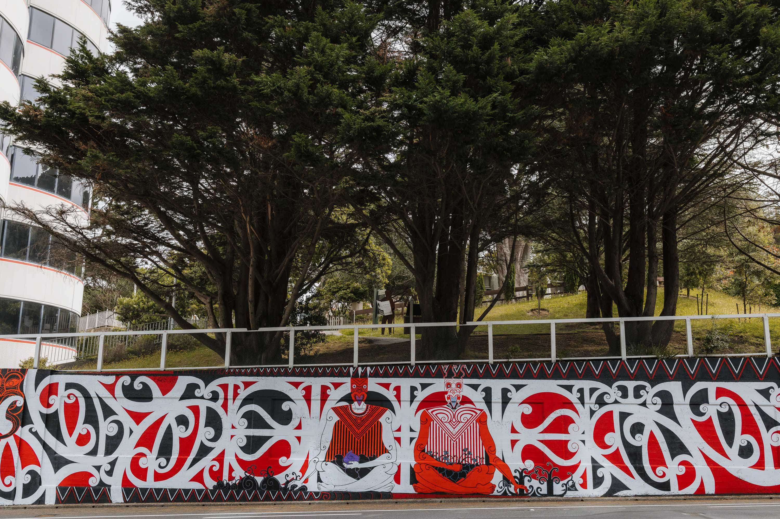

Infrastructure affordability and resilience challenges impact urban growth and regeneration
Construction in Wellington tends to be more expensive than in other New Zealand cities, which affects the affordability of high-density developments and Council-led projects. The city’s steep terrain, slip risk, difficult site access, and the need for complex structural engineering and construction techniques, along with new water infrastructure requirements (such as on-site detention of stormwater or wastewater storage for off-peak discharge) all contribute to these higher costs. The consenting process, especially for innovative projects, can also be complex and costly.

There are relatively few large-scale developers in Wellington capable of delivering affordable, high-density housing at scale. This limits the market’s capacity to address construction costs and results in fewer high-density projects.

Insurance risks and the multi-hazard urban environment are major concerns for urban regeneration. Some insurers have withdrawn coverage in certain areas due to the ongoing natural hazard risks, and underinsurance poses financial risks in the event of a major disaster. The Council faces an estimated underinsurance gap of $1.8–$2.6 billion for its assets, which leaves the city vulnerable.

The city’s electricity networks are under pressure, and costs for network upgrades are often passed onto the development that triggers the upgrade. Developers sometimes view this approach as inequitable.
Despite these challenges, efforts are underway to address them. The Council tracks development patterns using consent dashboards, housing and business capacity assessments, population projections, market studies, and other technical studies, working in coordination with other councils in the Wellington Region. Investment in the Wellington Underground Asset Map project has created a centralised, digital view of underground infrastructure, helping to reduce risk and uncertainty for urban development and construction. Better access to asset data enables more efficient planning, safer excavation, and improved coordination for new housing and infrastructure.

The new District Plan introduces more flexibility for business and mixed-use development and permits taller buildings, providing developers with broader options for projects. Coordination of land use and infrastructure can help shape the city’s changes. The update to the Wellington City Spatial Plan 2021 can help identify growth ranges for planning and prioritisation. Government proposals suggest using two different ranges: one for land use planning (high growth projections plus 20% to encourage market flexibility and reduce land prices) and another for infrastructure planning (based on the most likely demand scenario).
Transport, parks, and public space upgrades are also supporting urban intensification. The Council has pinpointed growth areas with limited access to neighbourhood parks and identified opportunities to upgrade public spaces. Projects such as the cycle network and bus priority lanes are expanding transport options and supporting regeneration.

Collaboration with landowners and developers is ongoing, particularly in areas where Council land and projects are involved, such as town centre upgrades, waterfront developments, and central city precinct planning. The Council also maintains staff and a fund to assist heritage building owners with the maintenance and restoration of historically significant properties.

Responding to climate change as the risks and costs increase
Wellington City is susceptible to long-term climate impacts: stronger storms and flash floods, land slips and worsening coastal flooding. These pose significant threats especially at Makara Beach and the southern coast.

The cost of infrastructure upgrades and future protections for public and private assets will rise over time as hazard risks increase. While the Council can coordinate community-led defences and asset relocation, it currently lacks the authority to require relocation or remove existing use rights.

Residents generally support the idea of taking action to reduce their carbon footprint and increase climate change resilience, however when consulted on specific, targeted actions many are reluctant to bear the associated costs themselves.
The Council has commitments both to adapt to climate change impacts and to work toward the goal of becoming a net-zero-carbon capital. The Council incorporates climate risk adaptation into its building projects where feasible, for example by designing coastal sea walls and roads to withstand sea level rise as estimated within the asset’s life span.

As outlined in the Paris Agreement, joining global efforts to reduce emissions is the most impactful way to limit long-term future global climate impacts. In Te Atakura First to Zero, the focus is on supporting the city to reduce emissions in several initiatives focused on urban development and form, waste and transport planning. Wellington City reports the lowest greenhouse gas emissions per person of New Zealand’s cities, supported by a compact city and high public transport use and the location of many carbon-intensive industries outside the city boundaries. City emissions have reduced 6% between 2020 and 2025, however, Wellington City is not currently on track to meet its 2030 57% greenhouse gas emissions target in Te Atakura. The 2025 Te Atakura Update reports graphs these emissions sources and reductions over time.

Future opportunities include:
- The government is proposing new statutory requirements and guidance for local climate adaptation planning, including in spatial plans, and has signalled a reduction in support for private property owners following extreme events.
- Collaborative planning with communities, iwi and hapū, alongside consistent standards for accessible and resilient urban infrastructure and design, should be prioritised in future adaptation efforts. Clear communication and options to fund adaptation actions will also be important.

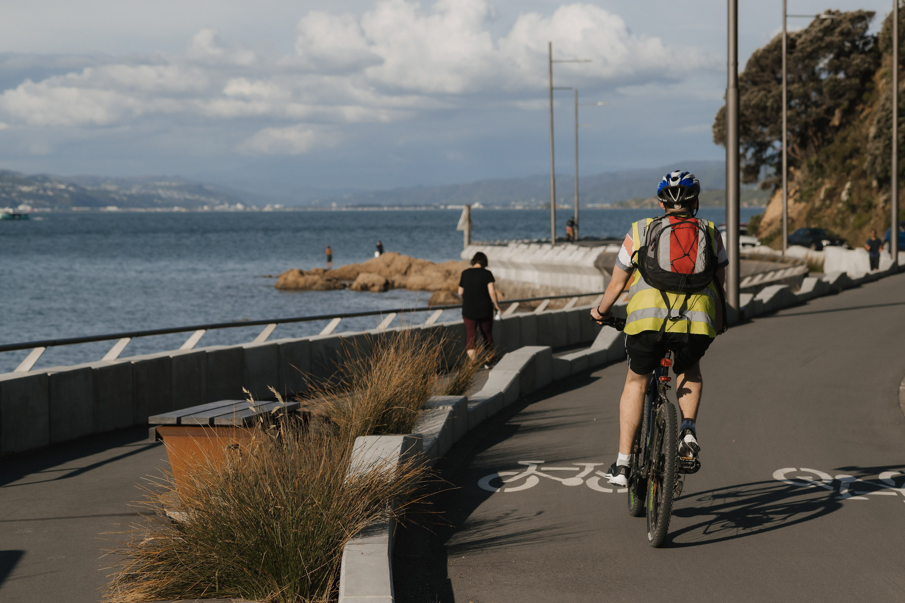

Public perception of safety and vibrancy continues to decline
Survey data indicates a notable decline in residents’ perceptions of Wellington’s city centre. Where over 80% of respondents considered the centre lively and attractive from 2014 to 2019, only 29% held this view in 2025. Pride in the city’s look and feel similarly dropped from 84% to 45%. Community feedback links these changes to safety concerns, often related to visible homelessness, substance use, and anti-social behaviour. Meanwhile, perceptions of local suburbs have remained stable since 2020, which may influence decisions about living in and developing high-density areas such as Te Aro.

Urban development and vibrancy in the city centre are shaped by the quality and activation of public spaces, as well as the presence of social issues like homelessness and substance use. The way public spaces are designed and maintained can either mitigate or exacerbate these issues.
There are opportunities to address these challenges through urban planning and design. The Council can improve public safety through thoughtful design of streets and public spaces, such as recent temporary changes to Dixon Street and Te Aro Park. Keeping areas clean, with trees and green spaces, encourages positive use and reduces the likelihood of damage. Areas that are perceived as safe, pleasant, well-connected, and close to parks and nature tend to be more highly valued and attractive for development.

The Council’s building projects support urban regeneration
Many Council building projects have experienced substantial cost increases compared to their original estimates. Various factors have contributed to these rising costs, including expanded project scopes, higher-than-anticipated design expenses, unforeseen underground conditions, and suppliers adjusting their pricing based on public commitments to specific outcomes and budgets.

Recent new and upgraded civic buildings, such as the Tākina Convention and Exhibition Centre, Johnsonville’s Waitohi Library, and the Moa Point Sludge Minimisation Plant, have been developed to support urban development and respond to changing community needs. The ongoing renewal of Te Ngākau Civic Square is also expected to enhance the vibrancy and economic activity of the city centre.

Changes to earthquake-prone building regulations have allowed some Council assets to avoid mandatory strengthening, which may help manage future costs. However, a number of these buildings still do not meet current standards, presenting ongoing safety and financial risks for both the Council and the community.

Over several years, the Council has investigated partnerships and land use development opportunities. Surplus Council-owned land, along with government land held by agencies such as NZTA and Kāinga Ora, has been leased, sold, or developed in collaboration with private partners. Continuing this approach has the potential to reduce reliance on rates funding for public services and contribute to improving the supply of housing.

Ageing assets, rising costs, and funding limitations
Infrastructure is one of the Council’s largest activity areas, including roads, pipes, parks, and community facilities. Wellington faces significant infrastructure challenges due to ageing assets, rising costs, and funding limitations. These challenges, and uncertainty on when the new infrastructure will be built, discourage urban development.

Three waters and transport infrastructure
Many three waters assets are ageing, and some have earthquake damage. While significant Council budgets were allocated to repairs and replacements, little funding (around 12-26 % of three waters budgets per year over ten years) has been allocated to new and upgraded three waters assets to support new urban intensification and growth.

The city has three main transport arterial pinch points when travelling out of the City Centre: narrow roads in Berhampore (south), Karori Tunnel (west), and Mt Victoria Tunnel (east). These constrain car, truck, public transport and cycling movement. They affect long term development potential in Karori and southern and eastern suburbs until works improve capacity, safety and travel time through them. Separate from transport improvements, the three waters infrastructure constraints discussed above remain major long-term constraints on urban development in these suburbs.

Addressing three waters and transport issues will need coordinated planning, a variety of funding solutions, and successful collaboration with partners.

The 2024 Long-term Plan set aside $1.8 billion for three waters renewals, services and repairs. This is helping improve development potential in areas where network capacity was previously lost from leaks and stormwater infiltration. Proposals to install water meters is also expected to help reduce average water demand per residence and so increase overall capacity and levels of service.

From July 2026, the three waters assets and funding will be transferred to Tiaki Wai Metro Water. It can source new funds from debt and user payments and can find operational efficiencies. The Spatial Plan update in 2026 is expected to guide where Tiaki Wai Metro Water should prioritise upgrades to enable urban development.

Planned state highway, rail and ferry projects offer opportunities to enable urban development.
- The SH1 Wellington Improvements may support urban regeneration in southeast Te Aro, Adelaide Road, Hataitai and the eastern suburbs generally.
- The proposed Petone to Grenada Link Road may connect current and future housing and business areas in Woodridge, Newlands and Grenada to the wider region.
- Rail service and resilience improvements on the Johnsonville Line, Kapiti Line and at the Central Station are improving long-term public transport to service more housing.
- CentrePort’s plans for ferry terminal upgrades and a cruise ship terminal may open up the northern inner harbour edge for public use and development.

The Spatial Plan update will help guide where the Council can prioritise transport funding across the city.

The Council’s new Infrastructure Strategy can help allocate costs across rates, targeted rates, development contributions and government contributions. Over time, population growth within existing urban areas can help fund infrastructure upgrades.

Integrating universal design into urban development
As more people live and work in compact urban environments, barriers to access become increasingly significant in daily life. With Wellington’s urban density rising and a wider variety of land uses emerging, accessible design is becoming more important. Residents and advocacy groups emphasise that accessibility goes beyond technical requirements, encompassing dignity, independence, and social inclusion.

Some community members have asked for clearer standards, stronger enforcement, and more consistent consultation with disabled residents and advocacy groups. Financial constraints can threaten the inclusion of accessible design features, particularly in projects with tight budgets or challenging sites, such as steep slopes or infill developments.

The Council is required, both legally and ethically, to ensure developments are accessible. Efforts are underway to incorporate universal design principles into Council projects. Universal design benefits people with disabilities as well as others, including parents with prams and older adults. These principles ensure that public spaces and buildings can be used by everyone, regardless of physical, sensory, or cognitive abilities.

Where possible, Council projects retain and install physical accessibility structures. When funding is limited, priority is given to actions that deliver the most widespread accessibility benefits. Major projects undergo accessibility audits to support this prioritisation.

Inclusion requires a considered approach
Community advocates and residents note that, during emergencies, elderly and disabled people in areas lacking full accessibility often face difficulties accessing essential services. A shortage of affordable housing further increases the risk of homelessness and violence, particularly for marginalised groups.

Funding limitations and feasibility challenges mean that the Council cannot always fully meet the needs of rainbow/takatāpui, youth, elders, migrants, and disabled residents. Nevertheless, the Council works towards enabling all residents, regardless of age, background, citizenship, or identity, to participate in city life. Recent initiatives have focused on improving the accessibility of housing, parks, transport hubs, and community facilities, as well as strengthening collaboration with iwi, hapū, and diverse communities.

To ensure marginalised perspectives are considered, the Council consults advisory groups representing disabled, ethnic, Pacific, takatāpui rainbow, and rangatahi youth communities. Feedback from these groups underscores the importance of inclusive public space design in promoting safety and a sense of belonging. Well-designed spaces help reduce barriers and foster social connection among rainbow/takatāpui and other marginalised communities.

Emergency management is improving, but has gaps for a sustained emergency response
Emergency management in Wellington faces notable challenges. There are concerns among emergency managers that the region’s councils may struggle to maintain emergency operations beyond 48 hours during a major disaster. This limitation means that volunteers, iwi, and community groups would need to step in to cover essential roles over extended periods. While these groups are crucial in emergency response, their resources may not fully meet public needs and expectations.

Efforts to address these challenges are underway. The Council’s emergency management responsibilities are now more closely linked with strategic planning, climate adaptation, and building regulation. This integrated approach aims to consider hazard risks early in decisions about urban infrastructure. For instance, the new District Plan guides development away from high-risk areas or seeks to reduce exposure to natural hazards. Upgrades to stormwater systems and the implementation of on-site retention measures are being designed to mitigate the impact of flood emergencies over the long term. At the same time, ongoing reforms at both regional and national levels are helping to reinforce the strategic direction of emergency management across the region.

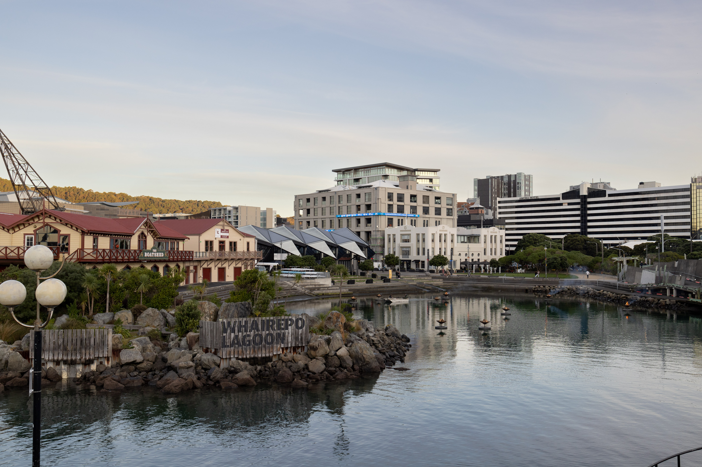

Wellington City Council. 2024 District Plan.
Te Ngākau Civic Precinct
Green Network Plan
Te Kāinga
Te Toi Mahana
Tiaki Wai Metro Water
Long-term Plan 2024-34 - Plans, policies and bylaws - Wellington City Council
Hon Chris Penk. (18 August 2025). Biggest building consent system reform in decades. Beehive.govt.nz.
Manatū Mō Te Taiao Ministry for the Environment. (24 March 2025). Reforming the resource management system – Replacing the RMA.
National Emergency Management Agency. (2025). Emergency Management Bill.
Wellington Region Civil Defence Emergency Management Group. (2025). Strategy 2025-2035.
Wellington Regional Leadership Committee. (2024). Regional Adaptation Project.
Sense Partners. (2025). Migration, births and deaths forecasts 2025-2056.
Sense Partners. (June 2025). Demographic forecasts for the Wellington Region. Statistics New Zealand’s demographers also provide population projections, which have Wellington City growing faster than the Sense Partners projections in the shorter term, but slower in the longer term.
Stats NZ. (2023). Census 2023.
Wellington Transport Analytics Unit & Welington Regional Leadership Committee. WRLC Regional dashboard – Housing and economics. Retrieved December 2025.
Infometrics. (2024). Housing affordability in Regional Economic Profile | Wellington City.
Wellington City Council. (2024). State of Housing: Wellington City.
Infometrics. (2024). Rent affordability in Regional Economic Profile | Wellington City.
This estimate incorporates what the District Plan allows, the cost of construction, the market sales prices, and the profit and risk margins for developers, for a range of small, medium and large houses, apartments and joined townhouses, both infill and demolish+rebuild. It does not account for infrastructure constraints (for example a lack of three waters services) or which locations and types of houses will be built first.
Property Economics. (June 2022). Wellington City commercially feasible residential capacity assessment.
around 200,000 new houses commercially feasible
Census 2023 found 19% of employed people in the Wellington Region mostly worked from home, an increase from 9% in 2018. The Household Labour Force Survey Sep 2024 found 33.5% of employed people in the Wellington Region worked hybrid: from home and at the employer’s location.
From CBRE July and September 2025: Christchurch 9.7%, Auckland 15.1%, Perth 15.5%, Adelaide 17.5%
Refer to studies from CBRE and Colliers from Q3 2025. Their estimates are different for secondary grade office buildings, but the same for prime buildings.
Witton. (29 September 2025). Earthquake-prone today, safe enough tomorrow: Rule change gives thousands of buildings reprieve. Stuff.
Hon Chris Penk. (29 September 2025). Earthquake-prone building system refocused. Beehive.co.nz.
Consultation on these was carried out by Global Research in 2023, 2022, and 2020, respectively.
Research carried out by Wellington City Council.
Kate Pascall to Whaitua Te Whanganui-a-Tara Committee. (19 August 2019). Wellington City Council: Planning for Growth.
For details on the weighting of these opinions, refer to these Global Research reports and the Section 42A report on the Proposed District Plan’s plan-wide matters and strategic direction.
The views on character precincts are summarised in the Character Precincts 42A Report paras 26-35.
Informetrics. (2024). Average rent in Regional Economic Profile | Wellington City.
Wellington City Council. (2024). State of Housing: Wellington City.
Infometrics housing register applicants
40% increase in September 2024
Downtown Community Ministry to RNZ
https://wellington.govt.nz/your-council/plans-policies-and-bylaws/policies/housing-strategy
Spatial Plan 2021
Ministry of Housing and Development & Ministry for the Environment. (June 2025). Going for Housing Growth: Providing for urban development in the new resource management system.
Wellington City Council. (June 2019). Te Atakura - First to Zero.
Infometrics. (2024). Greenhouse gas emissions per capita in Regional Economic Profile | Wellington City; Stats NZ (23 August 2023). Greenhouse gas emissions by region (industry and household): Year ended 2022.
2025 Te Atakura Update
For more information about the Karori Tunnel constraints refer to pages 71-73 of the internal document Wellington City Transport Plan Background paper 2024 – content available on request. More information is also in the Karori Tunnel Upgrade Option Report Beca 2004, and the Council’s Land Transport Activity Management Plan.
Waka Kotahi NZ Transport Agency. SH1 Wellington Improvements.
This means west-bound state highway traffic will tunnel under a new north-south road for vehicles and public transport, and pedestrian and cycling connections will be improved.
Waka Kotahi NZ Transport Agency. Petone to Grenada.
CentrePort Wellington. Our Plan.
The District Plan has an Inner Harbour Port Precinct which enables this land to be developed to align with the adjoining Waterfront Zone, into a mixed use environment of public spaces, buildings, visitor activities and transport.

