Kia ora,

We would like to inform you about a proposed change in your neighbourhood.

Proposal:

Reference | - TR23-25 Hutt Road, Kaiwharawhara – Proposed P15 Time Limited Parking
Location – where we propose to make the change | Outside no. 172 Hutt Road, Kaiwharawhara
What we’d like to do | - Convert three of the existing P10 7-9:30am, 4-6pm, Monday – Friday spaces, to three P15 8am-6pm, Monday – Sunday spaces
Why we are proposing the change | - Wellington City Council has received a request from a local business to convert some existing pick-up and drop-off spaces into P15 parking spaces.  - Council officers have reviewed the request and, to improve parking turnover, have proposed converting three spaces to P15 time-restricted parking, as shown in the plan below.
Impact | Improvements  - Improves the viability of business wellbeing  - Improves parking availability  Net Parking Impact  - Converting of three P10 spaces to P15 parking spaces  Pedestrian impact  - No Change
Other options considered | Option 1:  - Convert fewer parks to P15.  Option 2:  - Convert more parks to P15.  However, neither of these are preferred options as local businesses only requested three spaces to be P15.
How this relates to the parking policy | - Support business wellbeing – ensure parking management and pricing controls support economic activity in the central city, suburban centres and mobile trades and services.
Additional Information | - Average daily traffic count – 19,864  - To view the legal description for this Traffic Resolution, an electronic copy of the report will be available on the Council’s website from 9.00am Friday 21 February 2025 at https://www.letstalk.wellington.govt.nz/ or you can call (04) 499 4444 and we will send one out to you.
Privacy | - Your privacy is important to us. Please DO NOT add specific personal details to your feedback (i.e.: full name, address, etc)  - What we do with your personal information:  All submissions (including your first name, but not contact details) are provided in their entirety to elected members and made available to the public on our website and at our office. Personal information (including contact details) will also be used for the administration of the consultation process including informing you of the outcome of the consultation. All information collected will be held by Wellington City Council, 113 The Terrace, Wellington, with submitters having the right to access and correct personal information.  - For more information regarding our Privacy Statement please check our webpage: Privacy statement - Wellington City Council.
Feedback | - If you would like to provide us with specific feedback, which will be added to the Traffic Resolution following consultation and made public in full, you can do so by filling out an online submission form, downloading a printable submission form on https://www.letstalk.wellington.govt.nz/ or emailing us at trfeedback@wcc.govt.nz.  Please note if you are giving feedback the consultation period opens at 9.00am Friday 21 February 2025 and finishes at 5.00pm Friday 7 March 2025.
Next Steps | - Feedback collated by Monday 10 March 2025.  - The proposal will go to the Koata Hātepe|Regulatory Processes Committee meeting on Wednesday 9 April 2025.  - If approved, the proposal will be installed within the following three months.
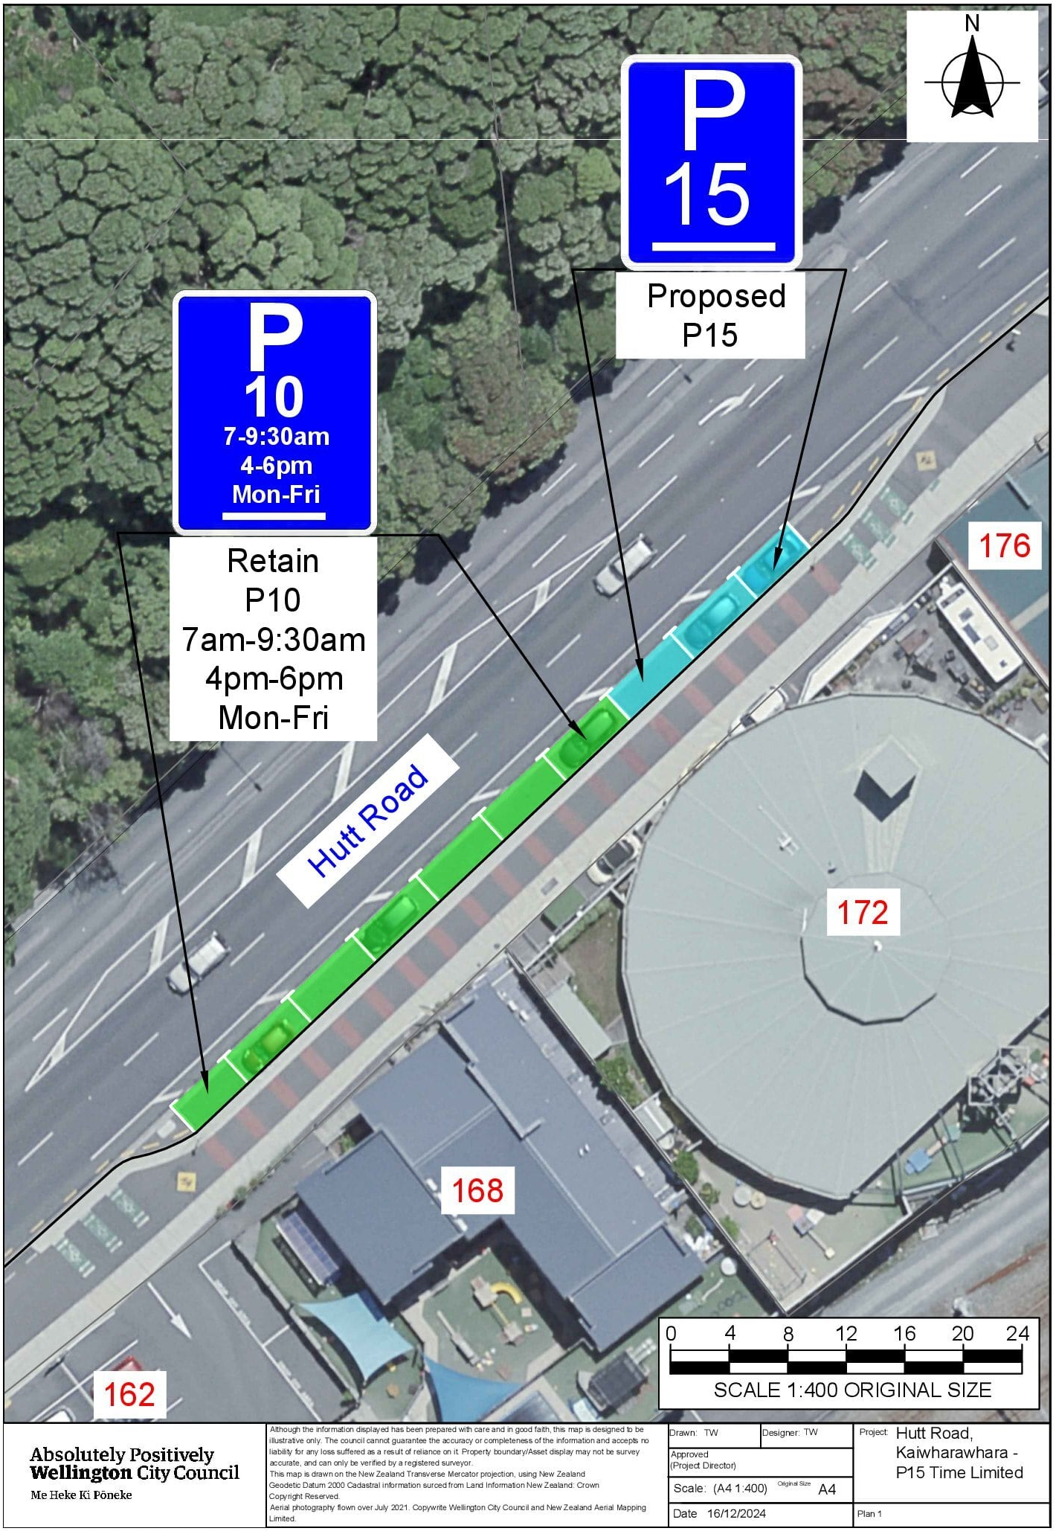
Traffic Resolution Plan: TR23-25 Hutt Road, Kaiwharawhara – Proposed P15 Time Limited Parking
Legal Description:

Add to Schedule A (Time Limited) of the Traffic Restrictions Schedule

Column One | Column Two | Column Three
Hutt Road | P10, 7am-9:30am  4-6pm  Monday – Friday | Southeast side, commencing 990 metres north of its intersection with Aotea Quay, Hutt Road Overbridge 1st Abut (Grid coordinates X=1,749,575.03m Y=5,430,447.30m) and extending in an northerly direction following the south eastern kerb line for 41 metres.

Add to Schedule A (Time Limited) of the Traffic Restrictions Schedule

Column One | Column Two | Column Three
Hutt Road | P15  8am-6pm  Monday – Sunday | Southeast side, commencing 1,031 metres north of its intersection with Aotea Quay, Hutt Road Overbridge 1st Abut (Grid coordinates X=1,749,575.03m Y=5,430,447.30m) and extending in an northerly direction following the south eastern kerb line for 17 metres.

Prepared By: | Tommy Wilson | (Transport Engineering Assistant)
Approved By: | Kate Gourdie | (Team Leader Traffic & Resolutions)
Approved Date: | 31/1/2025

