Significance and Engagement Policy
June 2018

ISBN: 978-0-947521-10-3

Significance and Engagement Policy

Introduction

Wellington City Council (the Council) makes decisions on behalf of its communities. The Council considers community views and preferences when making decisions and has flexibility about how it engages with communities. It gathers information about the views and preferences of Wellington’s diverse communities in many ways and uses this information to inform its decisions.

The Council aims to actively engage and work with its communities within its decision-making roles. Engaging early and well helps the Council make better decisions by making sure final decisions consider the views of the community and those affected by the decision. At times, and depending on the circumstances, engagement may need to go beyond the Council’s standard approach.

This policy explains how the community may be engaged in different types of decisions. The policy is required under the Local Government Act 2002 (the Act). It includes:

- The general approach to determining the significance of proposals and decisions (Parts 2, 3 and 4 of the policy).

- The criteria used to determine how significant proposals and decisions are (Schedule 1).

- Information about when, how and to what extent communities can expect to be engaged in decision-making processes and other matters (Parts 5 and 6).

- A list of strategic assets owned by the Council (Parts 10 and 11).

Making it work in practice

Council officers should answer some key questions to make this work in practice. Some decisions require the special consultative procedure under the Act.
See Part 7 of this policy for the requirements for these decisions.

For all other decisions, the Council must:

- Identify the aim — what is being sought and why.

- Identify all reasonably practicable options for achieving the aim.

- Assess the advantages and disadvantages of each option.

- Design the decision-making and engagement process, taking into account:

  - Whether the Council has enough information about community views on the matter. If not, further engagement or consultation may be appropriate.

  - Significance (see Schedule 1).

If the Council has decided to consult, or is legally required to consult, consultation must comply with the consultation principles (see Part 8).

The flowchart below illustrates this process.

6 Unless the special consultative procedure must be followed, which prescribes a process.

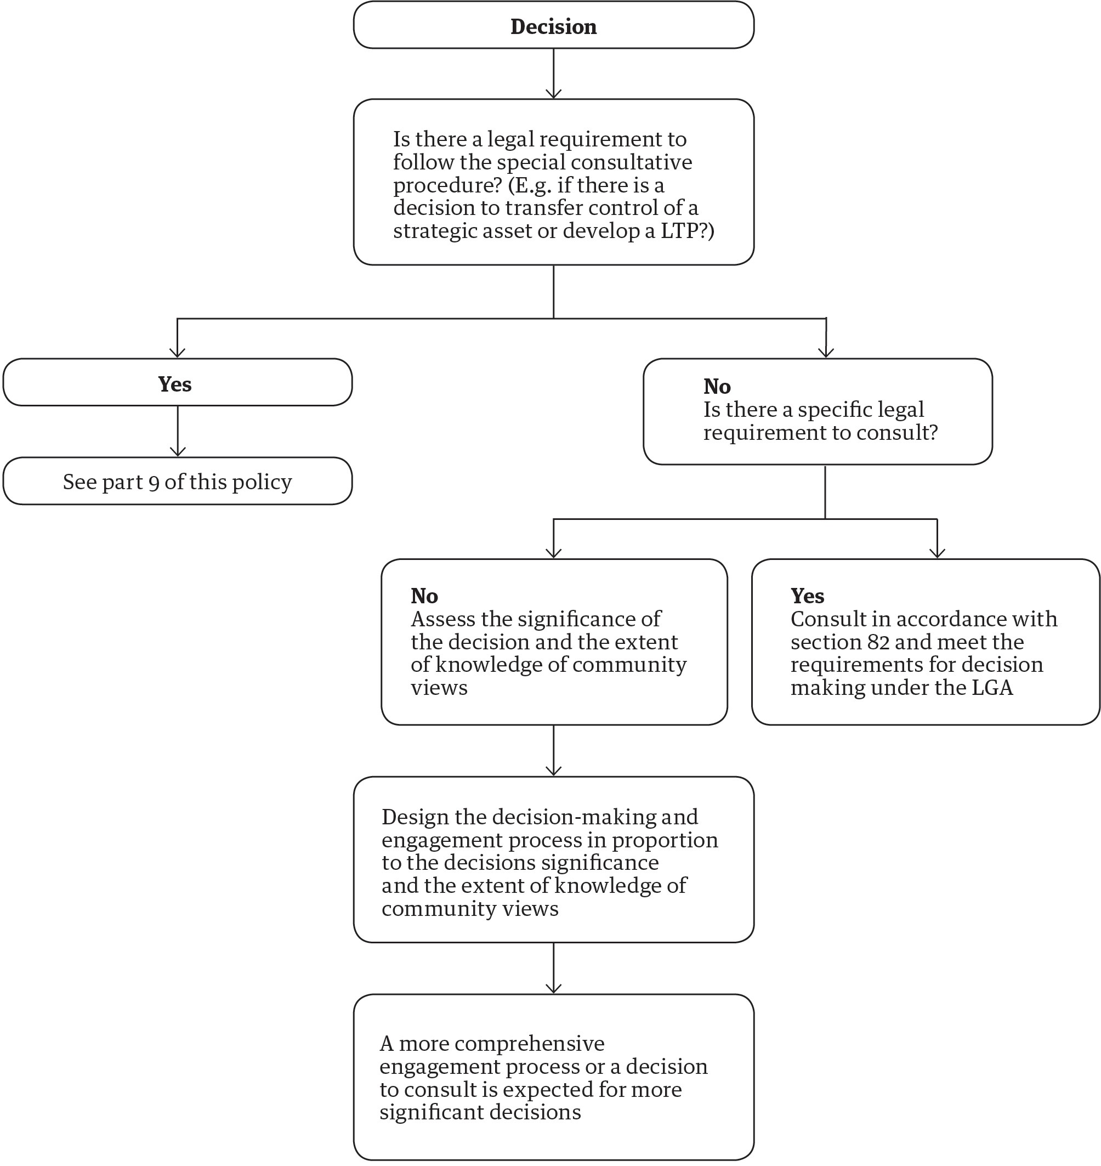

General approach

Consultation vs engagement

Consultation involves obtaining public feedback on proposals; it is one form of engagement. The Council regularly consults communities through process such as the long-term plan which determine Council’s strategic direction as well as how it sets budgets and prioritises projects.

The Council will consult the community on significant decisions, following the principles set out in section 82 of the Act (see Part 9). Council can also decide to consult at any time on a decision, where it considers that appropriate. For most Council decisions, there is

no express requirement to consult the public, but we will consider people’s views and preferences.

Engagement is a broader and ongoing process of sharing information with the community and seeking its feedback, with the purpose of involving the community in the process of decision making. This process may include a more formal consultation process to meet legal requirements. Our approach to engagement is set out in section 6.

There is a general expectation of officers that for more significant decisions they will have a communication and engagement plan which will apply the principles

of IAP2 engagement spectrum. Business units should work with engagement staff on how this can be applied to specific decisions.

The details of this are not included in this policy.

Assessment criteria

The Council must determine the level of significance of a decision based on criteria identifying the level of significance and the likely impact of the decision on the current and future wellbeing of the city. It must also take into account any persons likely to be particularly affected by or interested in the decision and the capacity of the Council to perform its role, as well as the financial and other costs of doing so.

The criteria for assessing the degree of significance

The Council’s criteria for assessing the degree of significance of a decision are:

- the level of importance to Wellington City

- the level of community interest

- the consistency of the proposed decision with existing policy and strategy; and

- the impact on the Council’s capacity and capability.

The key factors to consider under each criteria are set out in Schedule One, on the following page. When a decision is indicated as “high” on two or more criteria it is likely to be highly significant.

Factors that guide the Council’s decision making process

Decisions of high significance in the Long-term Plan

Decisions assessed to be of high significance to the Council and the community should normally be included in the Long-term Plan (LTP) process. This will ensure that they are linked to community outcomes, proposed in context with other major decisions, and put before the community within this planning and consultation process and timing.

Making decisions of high significance outside of the Long-term Plan

There will be decisions of high significance that must be made outside of the Long-term Plan process. The Council will ensure an appropriate engagement and decision-making process is followed and that this is addressed in a report to the Council. The Council will use the special consultative procedure when it is legally required to. Part 8 sets this out in more detail.

Reporting of decisions

All reports by officers to Council or a Council Committee which are seeking a decision will include a statement addressing the issue of significance. If the proposal is considered to be of high significance the report will describe how the relevant sections of the Act and this policy have been addressed.

When might the Council not carry out engagement?

There may be occasions when the Council may not follow this policy, for example where failure to make a decision urgently would result in unreasonable or significant damage to property, risk to people’s health and safety, or the loss of a substantial opportunity to achieve the Council’s strategic objectives. The Act sets out a process for the Council to follow if the Council has a good reason to make a decision outside of this policy.

Other Council decisions and levels of reporting

For decisions of low or medium significance, the Council will comply with sections 76 to 82 of the Act. For decisions to be made under delegated authority and for which there is no Council or committee report, the Council will not necessarily formally document the assessment of significance or the Council’s compliance with sections 76 to 82.

The Council will ensure that, in fulfilling the above requirements, the level of attention, consideration, disclosure, and engagement taken is in proportion to the significance of the decision.

The Council will continue to make available all information regarding the decisions it makes in response to all written and verbal submissions from individuals and groups in the community.

170 WELLINGTON CITY COUNCIL | OUR 10-YEAR PLAN 2018–28 SIGNIFICANCE AND ENGAGEMENT POLICY

Schedule 1: The criteria and factors for assessing significance

Rating | Criteria | Key factors to be considered | Engagement
High  For example: The Long-term Plan, decisions to transfer strategic assets to or from the Council or to significantly alter the level of service provided by the Council of a significant activity.  When a decision is indicated as high on two or more criteria it is likely to be highly significant. | Importance to Wellington City  Community interest  Consistency with existing policy and strategy  The impact on the Council’s capacity and capability | - Any decision that would significantly alter the level of service provided by the Council of a significant activity, including a decision to commence or cease such an activity.  - Extent of costs, opportunity costs, externalities and subsidies.  - Uncertainty, irreversibility, and the impact of the decision in terms of the community’s sustainability and resilience.  - High levels of prior public interest or the potential to generate interest or controversy.  - Large divisions in community views on the decision.  - A moderate impact on a large proportion of the community or a high impact on a moderate number of persons.  - Decisions that are substantially inconsistent with current policies and strategies.  - High capital or operational expenditure.  - A financial transaction with a value of greater than 10 percent of rates revenue in the year of the decision. | Large-scale publicity and promotion. This may include an informal phase followed by more formal forms of engagement. Promotion through a range of channels and events, potentially including hui, a focus on online activities, newsletters and publications.
Medium  For example: Works on main roads and action plans. | Relationship to factors under high and low significance criteria. | Factors that sit between high and low significance. | If the Council chooses to conduct engagement it might include localised promotion, for example display boards and local media, briefings, the website or social media. Targeted engagement, for example through service users, where appropriate. Information online and in local libraries and service centres, surveys and open days may be appropriate.
Low  For example: Redevelopment of community halls, park improvements, footpath and road works. | Relationship to factors under high and low significance criteria. | - Affects a limited number of individuals, to a low degree.  - Has very little public interest.  - Low consequence for Wellington City.  - Low impact on the Council being able to perform its role.  - Able to be reversed.  - Is a strong logical step from a prior decision. | If the Council chooses to conduct engagement, targeted engagement with the affected audience, online engagement with surveys or social media, information through libraries or service centres, or promotion through local media.

- The type and nature of the decision will guide how the Council will go about communicating and engaging with its communities. The Council will consider the extent to which community views and preferences are already known in designing the engagement process. This table provides an indicative guide to this.

3. The Council’s approach to engagement

Early engagement

The assessment of the significance of proposals and decisions, and the level of community engagement, will be considered in the early stages of a proposal before decision making occurs and, if necessary, reconsidered as a proposal develops. The aim is to engage early so that the decision-making process is well informed by those impacted by any decision.

Informed engagement

The Council uses the International Association of Public Participation (IAP2) spectrum and decision- orientation approach which indicates different engagement approaches on a spectrum from providing information through to community empowerment.

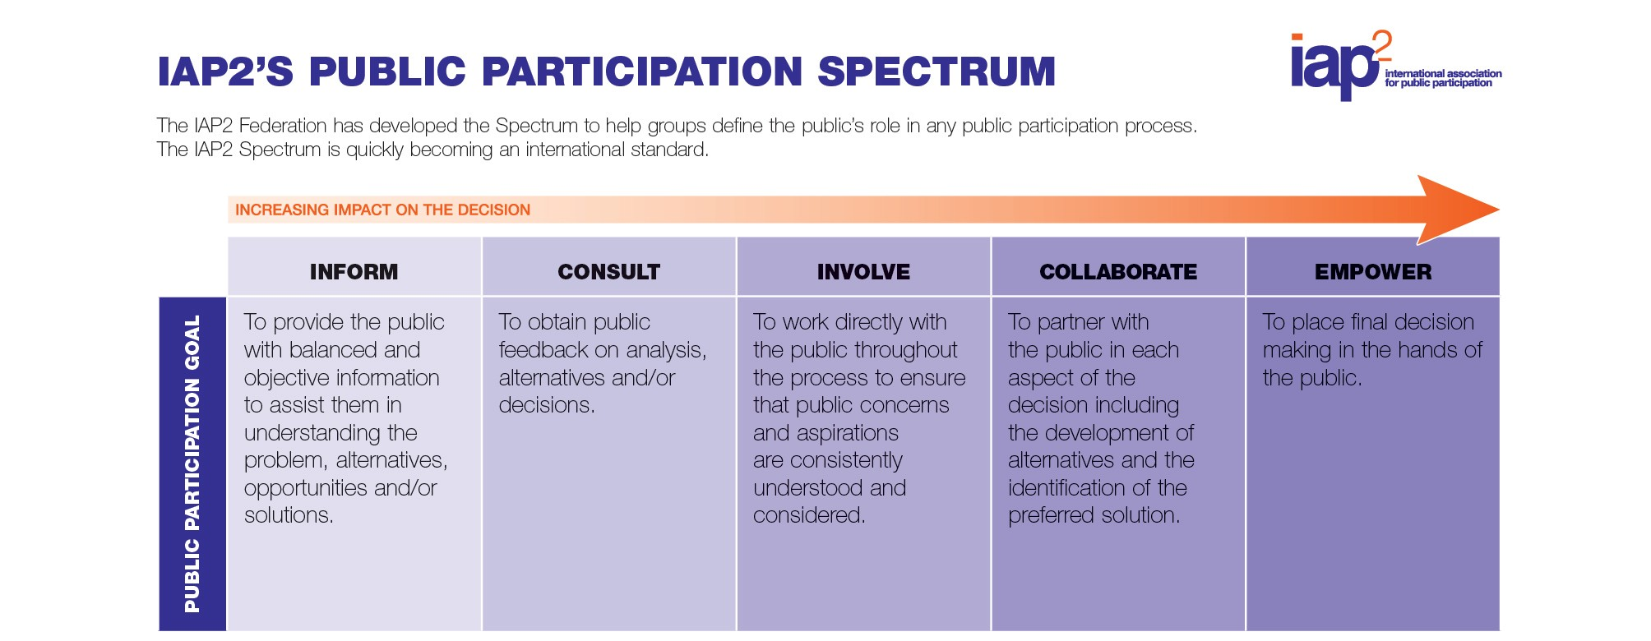

The IAP2 Spectrum allows for different levels of engagement depending on the decision; it does not intend for all of the levels of engagement captured on the spectrum to be applied.

How does the Council engage?

The Council actively seeks to improve opportunities for engagement and ensure that final decisions take into account or have regard to the views of the community and those affected by the decision. The Council will monitor and report on how public input has influenced decisions. The Council works with communities on a number of levels including as customers, stakeholders, citizens, ratepayers, subject matter experts and partners. It views engagement as a genuine dialogue with its diverse communities to help Council make better decisions. Council has working relationships with groups including:

- mana whenua, iwi and Māori organisations

- community and business organisations

- government and education sectors

- residents and ratepayers.

The Mayor and Councillors have a responsibility to ensure there is effective community engagement. The Council’s Community Boards are also responsible for communicating with local communities to help inform and communicate local communities’ views.
As well as consulting on certain decisions we will seek to establish ongoing relationships with our communities to provide opportunities for matters to be raised which are not currently under consultation. We may do this in a variety of ways such as having a presence at markets and public spaces, through our ongoing conversation channels, front line staff, workshops and community events. The following is a list of channels the Council uses to have conversations with the community:

- Facebook

- Annual Plans

- Twitter

- Reception

- Committee meetings

- Festivals

- Forums

- Libraries

- Long-term Plans

- Radio

- Website

- Councillors

- Events

- Research panels

- Community boards

- Newspapers

- Surveys

- Front desk

- Community centres

In any engagement programme, the Council will consider how to meet the needs of our communities in respect of language, accessibility and cultural expectations. When the Council identifies a group that it believes should be involved but which is less able to participate due to capacity or skills required it may provide assistance to enable the group to participate.

We will involve participants who can provide information and expertise the Council may not otherwise have access to.

The Council will work with groups that represent a community or sector recognising that early engagement can facilitate improved mutual understanding between groups with different aspirations and perspectives.

Engagement with Māori

The Council acknowledges the unique status of Māori and the wider Māori community and is committed to ensuring that it provides opportunities for Māori to contribute to in the decision-making process. The Council is committed to providing relevant information to inform Māori contribution and improve Māori access to the Council’s engagement and
decision-making processes, as set out in section 81 of the Act.

The Council will work with the city’s two mana whenua iwi, the Port Nicholson Block Settlement Trust and Te Rūnanga o Toa Rangatira Incorporated, to ensure their contributions are represented and their status is publicly recognised. The Council recognises that early engagement with iwi is often the most effective – in particular for those decisions which have greater significance.

The Council affirms its obligations to involving Māori in decision-making processes as set down in the Act, which includes recognition of the Treaty of Waitangi.

4. Policy review

The Council will review the Significance and Engagement Policy every three years or as required. This will be amended and confirmed through public consultation if necessary, separately or as part of the Long-term Plan.

5. Special consultative procedure

The special consultative procedure requires the Council to prepare a statement of proposal and make this publically available (and make the summary or a full proposal widely available). It must allow feedback of at least 1 month. Council must ensure people are given an opportunity to present their views to Council through spoken interaction (or using sign language).

The Council must use the special consultative procedure for some plans and processes including:
- adopting or amending a Long‐term Plan;
- adopting, amending, or revoking bylaws of significant interest to or impact on the public (for all other bylaw matters the Council will consult following the principles in section 82 of the LGA);

- adopting, amending or revoking a Local Alcohol Policy; and

- setting rates.

Unless already explicitly provided for in the Long-term Plan, we will seek to amend the Long-term Plan using a special consultative procedure, when proposing to
alter significantly the intended level of service provision for any significant activity undertaken by or on behalf of Council, including commencing or ceasing such an activity; and when transferring the ownership or control of strategic assets, as listed in Part 11.

In these circumstances the Council will develop information that meets the requirements of section 82A of the Act, making this available to the public, allowing submissions for a period of at least 1 month, and will consider all submissions prior to making decisions.

6
Principles of consultation

When carrying out consultation, Council will follow these principles of consultation (from section 82 of the Act)

- identify people who will or may be affected by, or have an interest in, the decision;

- provide them with reasonable access to relevant information in an appropriate format on the process and scope of the decision;

- encourage people to give their views;

- give people a reasonable opportunity to present their views in an appropriate way;

- listen to, and consider those views, with an open mind; and

- after the decision, provide access to the decision and any other relevant material.

Where the Act requires Council to consult on a particular draft policy or decision, Council will prepare and make available:

- a description of what it intends to do, and why;

- an analysis of the practical options (with advantages and disadvantages); and

- a draft of the policy or relevant document (or details of the changes to any policy or document).

7. Strategic assets

The Act requires that any decision that significantly alters the level of service provided by the Council of a significant activity (including a decision to commence or cease such an activity) or transfers ownership or control of a strategic asset to or from the Council must be explicitly provided for in the Long-term Plan and can only be consulted on in the Long-term Plan, in accordance with section 93E of the Act8.

Legal framework Strategic assets are defined in section 5 of the Act as: “...an asset or group of assets that the local authority needs to retain if the local authority is to maintain the local authority's capacity to achieve or promote any outcome that the local authority determines to be important to the current or future well- being of the community; and includes:

- any asset or group of assets listed in accordance with section 76AA(3) by the local authority; and

- any land or building owned by the local authority and required to maintain the local authority's capacity to provide affordable housing as part of its social policy; and

- any equity securities held by the local authority in:

  - a port company within the meaning of the Port Companies Act 1988:

  - an airport company within the meaning of the Airport Authorities Act 1966.”

Section 76AA (3) of the Act requires that the Council “must list the assets considered by the local authority to be strategic assets.” These assets are determined to be important to achieving the Council’s community outcomes. In addition, assets or groups of assets are listed as strategic if the Council ownership or control is essential to the long-term provision of the associated service.

Group or whole-of-asset approach

The Council takes a group or whole-of-asset approach9
i.e. it means the group assets as a whole and not each individual asset within the group. Without limiting the application of this provision to other assets, the following examples of the application of this policy to group assets are given:

- “Water supply network assets” means those group assets as a whole and not each individual pipeline, reservoir, and pump station. The Council does not consider that the addition or deletion of parts of that group asset (being a part of the group asset as a whole) will affect the overall group asset’s strategic nature.

- “Roading assets” and “reserve assets” mean those group assets as a whole. Therefore, if the Council acquires land for a new road (or the formed road itself) or new reserve lands as a result of subdivision, those additions are part of the day-to- day business of managing the roading and reserves assets.

- Decisions that involve the transfer of ownership or control of an element of a group strategic asset where the remaining assets of the group still enable the Council to meet its strategic outcome will not on their own be regarded as a strategic asset. Examples include:

  - decisions to facilitate the development of the waterfront in accordance with the Waterfront Framework (April 2001) or other similar policy for the waterfront

  - disposal of former roads, provided that the Council has followed the road stopping processes under the Public Works Act 1981

  - disposal of individual reserves, provided that the Council has followed the procedures in the Reserves Act 1977 or the Local Government Act 2002 for areas managed as reserve but not covered by the Reserves Act. The Wellington Town Belt Act 2016 does not allow removal of land from the Wellington Town Belt except
under the provisions of the Public Works Act 1981.

- Section 93E of the Local Government Act 2002 covers the additional content of consultation documents for adoption or amendment of a Long-term Plan where section 97 applies to proposed decision.
- Does not apply to equity securities in Wellington International Airport Limited

Schedule of Strategic Assets

Assets the Council owns that are strategic assets under section 5 of the Local Government Act 2002:

- equity securities in Wellington International Airport Limited10

- the public rental housing held by the Council to maintain affordable housing

Assets the Council has determined to be strategic assets:

- the sewage collection, treatment and disposal system, including the sewer network, pump stations and treatment works

- the land drainage system, including the stormwater pipe network, waterways, and retention areas.

- the water supply system, including reservoirs, pump stations and reticulation

- the roading network, including the public transport infrastructure system and pedestrian networks

- the shareholding in Wellington Cable Car Limited

- the library service

- swimming pool facilities

- the ASB Sports Centre and network of recreation centres

- community centres

- waterfront land and assets held on trust by Wellington Waterfront Limited for the Council

- all of the land and buildings in the area within the Civic Square Heritage Area, as defined in the Design Guide in the District Plan (Volume 2 - Area 5)

- the Wellington Town Hall

- the Michael Fowler Centre

- the buildings and collections of the Wellington Museum, City Gallery, Colonial Cottage Museum, Wellington Cable Car Museum and the Carter Observatory

- St James Theatre, Opera House, and the Embassy Theatre

- artwork and literature collections, including public art and collections held by libraries

- reserves lands, including the Wellington Town Belt, land held under the Reserves Act and land used for parks, cemeteries, gardens, sports fields and recreational areas

- the core data set used to deliver Council services

- the Council’s brand, Absolutely Positively Wellington - Me Heke ki Pōneke

- Wellington Zoo

- the assets of Zealandia – the Karori Sanctuary Trust that are owned by the Council

- Kiwi Point quarry

- Southern Landfill.

- The Council’s group or whole-of-asset approach does not apply to these assets

0
t;;
<D 0 Q

Absolutely Positively
Wellington CityCotincil
Mc HcR KiP6ndr

