Kia ora,

We would like to inform you about a proposed change in your neighbourhood.

Proposal:

Reference | - TR37-26 Norwich Street, Wadestown - No Stopping At All Times
Location – where we propose to make the change | - Outside no.47 Norwich Street to no.55 Wilton Road and outside no.42 to no. 40 Norwich Street (Plan 1)  - Between no.3 and no.8 (Plan 2)
What we’d like to do | - Formalise Bus Stop #5936 by installing adequate road markings.  - Install No Stopping At All Times (Broken Yellow Lines)
Why we are proposing the change | Plan 1  - Wellington City Council and Greater Wellington Regional Council/Metlink have worked together to resolve ongoing safety, access, and operational issues at the Norwich Street bus terminus. The site currently has one formal stop (#4936), while a previously informal stop (#5936) was removed after resident concerns. Limited space means buses sometimes block the intersection while waiting, creating safety risks. The proposal is to reinstate stop #5936 in a safer, set-back location, allowing buses to turn, wait off the intersection, and provide a clear, designated area for passenger boarding. Overall, the plan aims to improve safety, efficiency, and passenger experience while addressing community concerns.  - There are brief periods each day when multiple buses converge at the terminus, causing temporary waiting at stop #5936 because no dedicated layover space is available. This is not a scheduled layover, though slightly longer waits may occur during two short windows (around 9:30–9:46am and 3:39–3:48pm). Currently, buses dwell in less safe locations, but the new stop #5936 will provide a safer, designated space for this purpose.  - GWRC/Metlink carried out a two-week pre-consultation (15 April–1 May 2026) with 22 properties on Norwich Street and Wilton Road, receiving 7 responses. Most (5) supported the proposal, mainly to make stop 5936 a more accessible drop-off point, especially for elderly or mobility-impaired residents. Two objected, citing concerns about road width and potential congestion, which are addressed by proposed No Stopping lines.  - Additionally, the proposed broken yellow no stopping lines at the intersection will facilitate buses completing a 180-degree turn at the end of Norwich Street by preventing obstruction from parked vehicles which is a current issue.Plan 2  - Council have received accessibility concerns from residents regarding on-street parking conditions on upper Norwich Street. Due to the narrow width of the roadway, current parking practices are contributing to congestion and making it difficult for vehicles, particularly buses, to safely navigate the street.  - Following a site investigation, Council officers identified that the combination of the road width and the curvature of the bend at this location restricts vehicle movement, especially for buses. While the carriageway may appear sufficiently wide enough, parking in certain locations results in obstructions. Please refer to the proposed plan, which identifies the specific locations where Council officers propose installing broken yellow lines to prevent obstruction and allow all vehicles to travel safely in both directions.  - After an initial two-week consultation beginning 12 January 2026 with the residents in the immediate area, it was agreed to move forward with this proposal.
Impact | Improvements  - Improves bus service  - Improves driver visibility  Net Parking Impact  - Removal of three unrestricted parking spaces in Plan 1  - Removal of four unrestricted parking spaces in Plan 2  Pedestrian impact  - Improves access to bus services with a dedicated bus stop and waiting area.
Other options considered | Options for Plan 1:  Nine options were assessed across safety, affordability, deliverability, driver wellbeing, customer impact, and community impact. A summary of the breadth of options considered are below:  - Service reduction or timetable redesign (undermines reliability and network value)  - Extending Stop #4936 to accommodate more than one bus. This was not supported, due to risk of visibility being obstructed at the intersection with Wilton Road and it is illegal to park within 6 metres of an intersection.  - Alternative terminus locations (high cost, loss of existing driver toilet, community displacement/loss of bus service access)  Options for Plan 2:  - Another option was considered to have the broken yellow lines that are being proposed outside no.6 to be outside no.5 instead as Council generally prefer parking where there is a footpath. However, in doing so would remove a significantly higher number of parking due to how busses travel up Norwich Street and this option was not preferred by both Council officers and residents during the initial consultation.
How this relates to the parking policy | - Support shift in type of transport used – facilitate a shift to using active (eg, walking and cycling) and public transport through parking management and pricing, to move more people driving fewer vehicles.  - Support safe movement – facilitate the safe and efficient movement of people and goods by focusing on people moving along transport corridors rather than people parking or storing stationary vehicles.
Additional Information | - Average monthly passenger number (March 2026)– Stop #4936: 484 (boarding), 58 (alighting). No data for stop #5936 as it is not an official bus stop in Metlinks system.  - Average daily traffic count – 420  - An electronic copy of the report will be available on the Council’s website from 9.00am 10 June 2026 at https://www.letstalk.wellington.govt.nz/
Privacy | - Your privacy is important to us. Please DO NOT add specific personal details to your feedback (i.e.: full name, address, etc)  - What we do with your personal information:  All submissions (including your first name, but not contact details) are provided in their entirety to elected members and made available to the public on our website and at our office. Personal information (including contact details) will also be used for the administration of the consultation process including informing you of the outcome of the consultation. All information collected will be held by Wellington City Council, with submitters having the right to access and correct personal information.  - For more information regarding our Privacy Statement please check our webpage: Privacy statement - Wellington City Council.
Feedback | - If you would like to provide us with specific feedback, which will be added to the Traffic Resolution following consultation and made public in full, you can do so by filling out an online submission form, downloading a printable submission form on https://www.letstalk.wellington.govt.nz/ or emailing us at trfeedback@wcc.govt.nz.  Please note if you are giving feedback the consultation period opens at 9.00 am 10 June 2026 and finishes at 5.00 pm 24 June 2026.
Next Steps | - Feedback collated by 25 June 2026.  - The proposal will go to the Te Takere|Regulatory Processes Committee meeting on 5 August 2026.  - If approved, the proposal will be installed within the following six months.

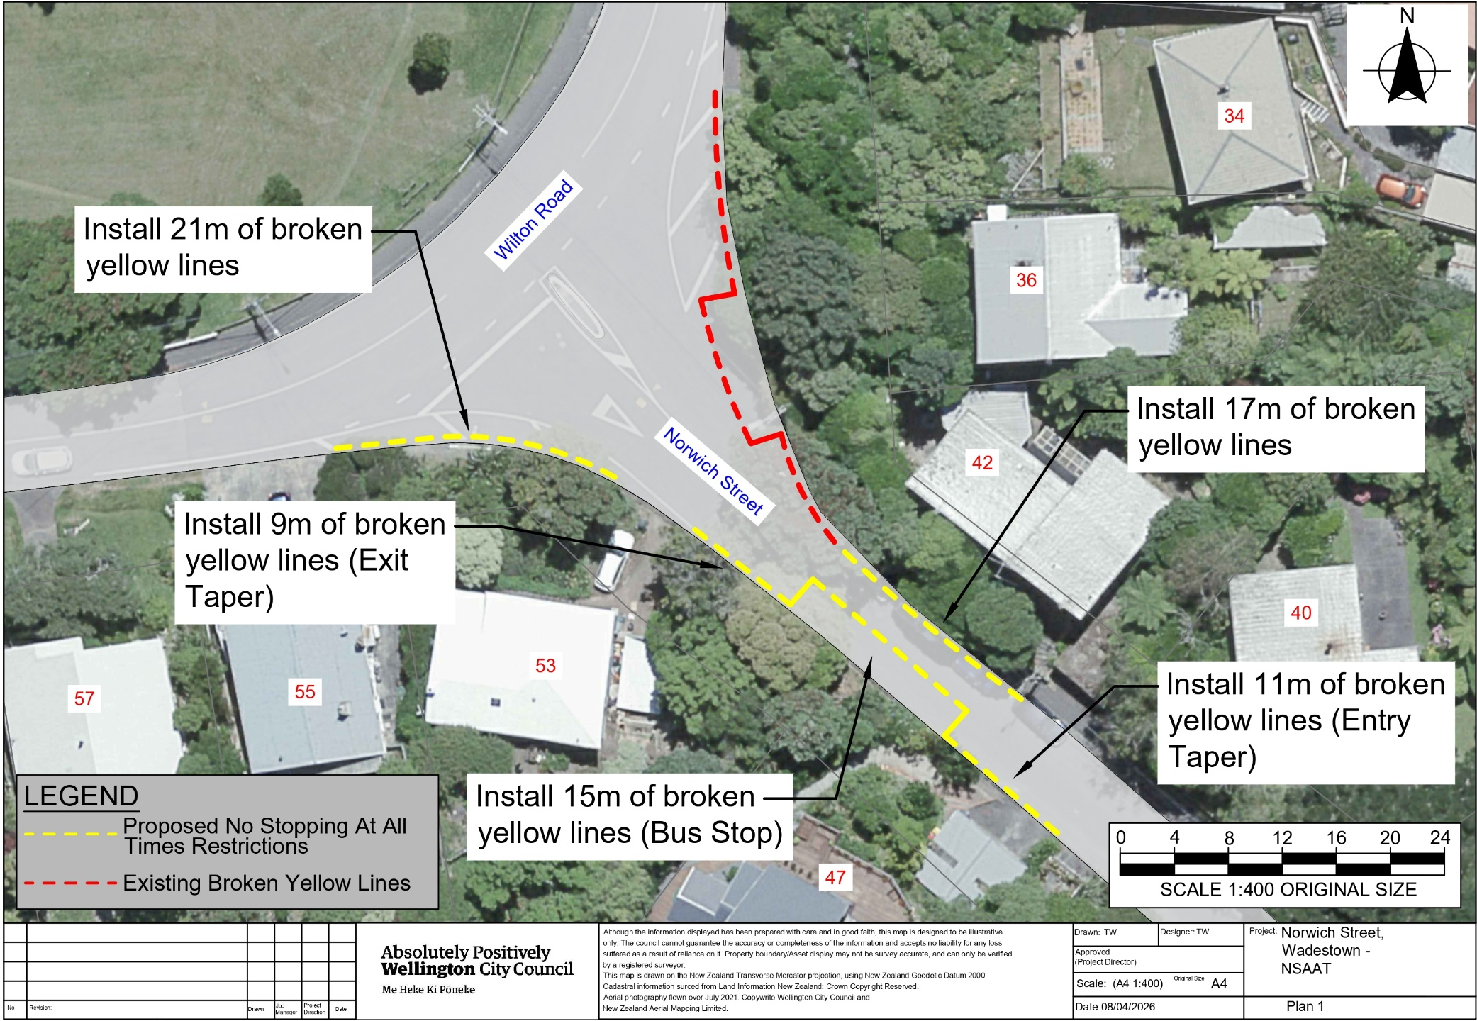
Traffic Resolution Plan 1: TR37-26 Norwich Street, Wadestown – Bus Stop and No Stopping At All Times

Plan 2: TR37-26 Norwich Street, Wadestown – Bus Stop and No Stopping At All Times

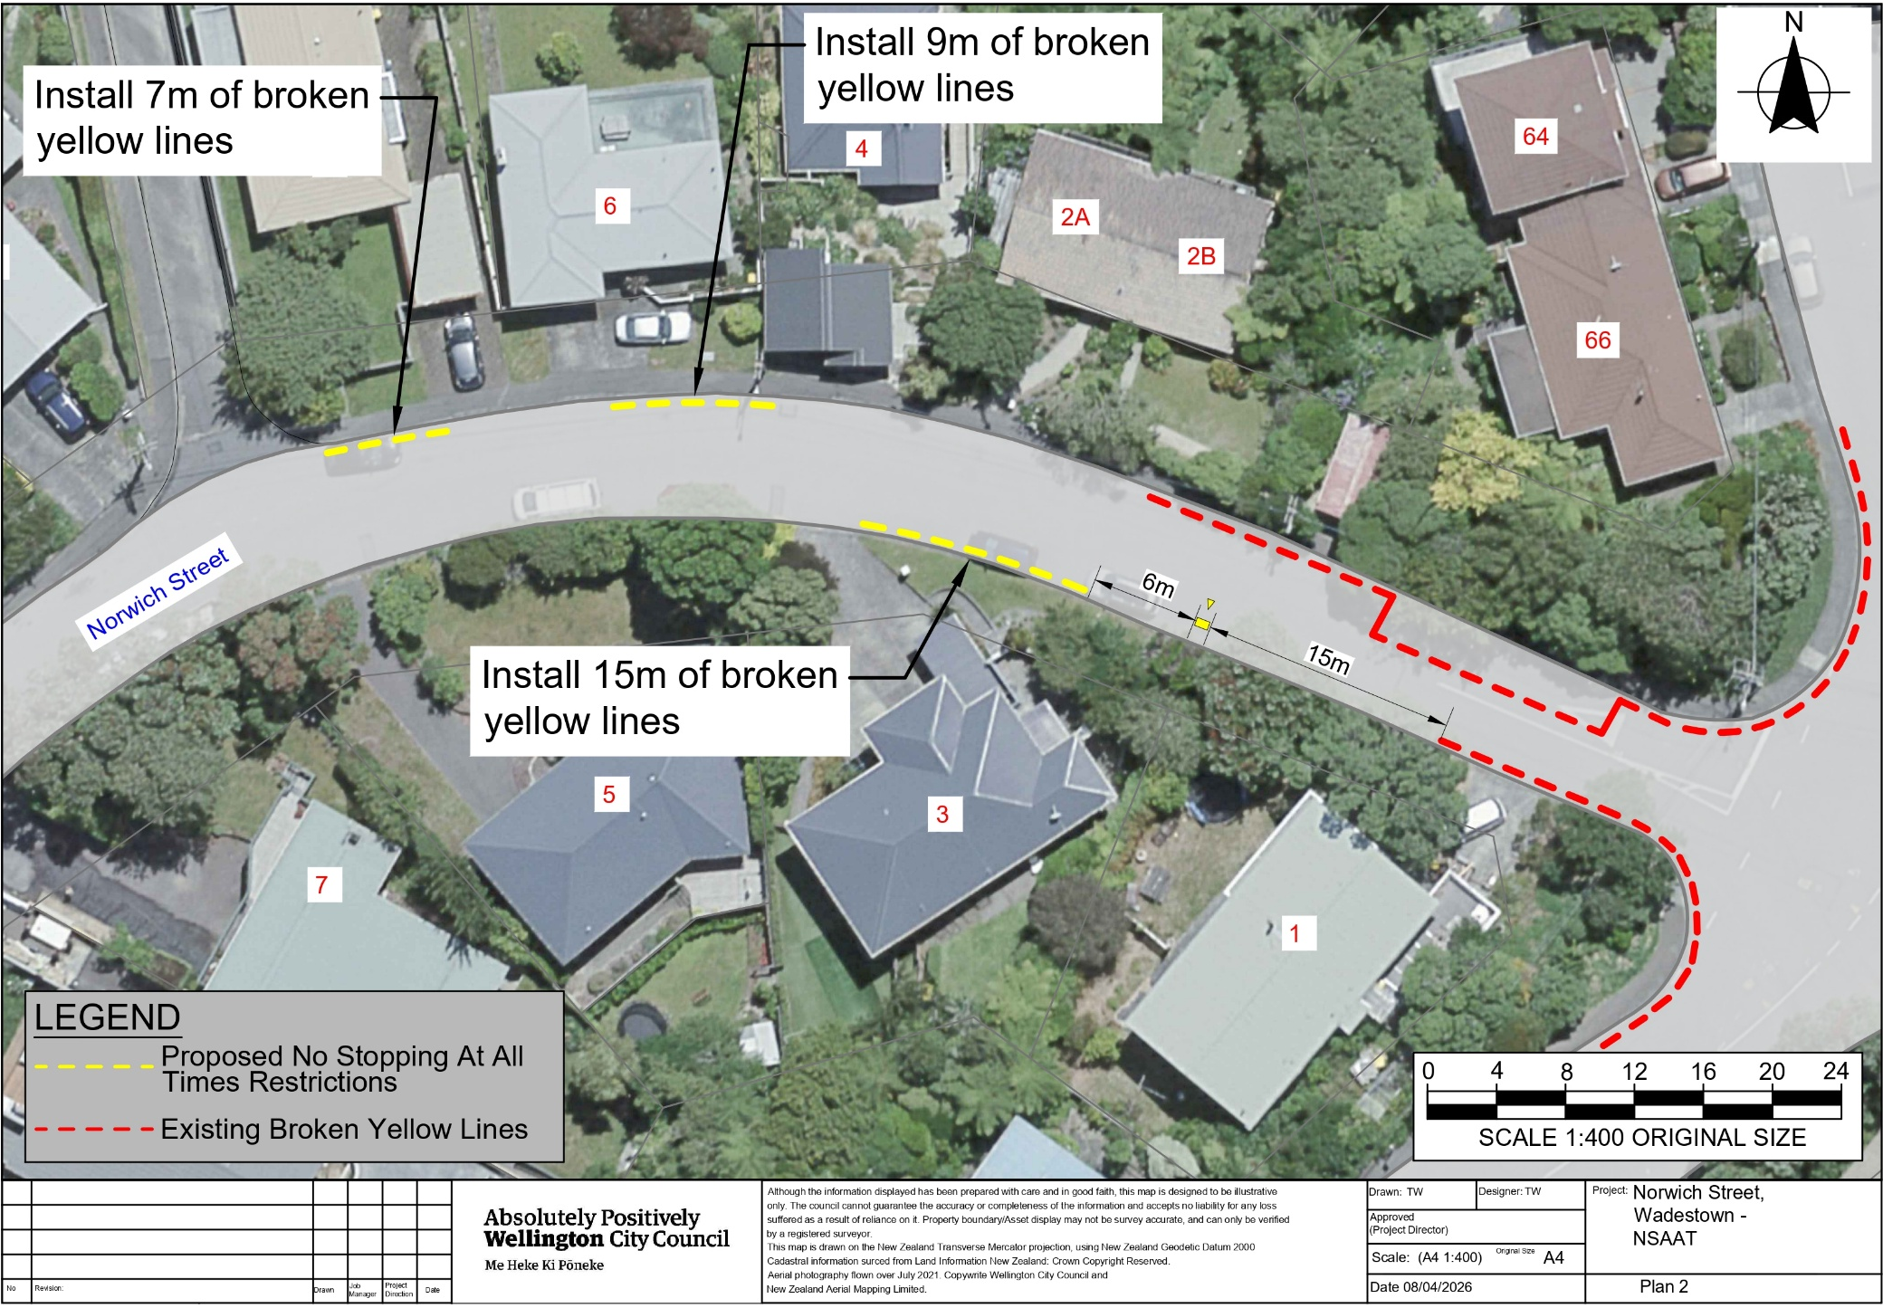

Legal Description

Delete from Schedule D (No stopping) of the Traffic Restrictions Schedule

Column One | Column Two | Column Three
Norwich Street | No Stopping At All Times | North-eastern side, commencing 2.4 metres south of its intersection with Wilton Road (Grid coordinates X=1,747,778.23m Y=5,430,333.78m) and extending in a south eastern direction following the northern kerb line for 15 metres.
Norwich Street | No Stopping At All Times | North-eastern side, commencing 21.3metres south of its intersection with Wilton Road (Grid coordinates X=1,747,780.79m Y=5,430,308.60m) and extending in a south eastern direction following the northern kerb line for 9 metres.

Delete from Schedule B (Class Restricted) of the Traffic Restrictions Schedule

Column One | Column Two | Column Three
Norwich Street | Bus Stop, At All Times | North-eastern side, commencing 11.3 metres south of its intersection with Wilton Road (Grid coordinates X=1,747,779.65m Y=5,430,318.86m) and extending in a south eastern direction following the northern kerb line for 15 metres.

Add to Schedule D (No stopping) of the Traffic Restrictions Schedule

Column One | Column Two | Column Three
Mairangi Road | No Stopping At All Times | Northwestern side, commencing at its intersection with Norwich Street (Grid coordinates x= 1,747,980.08m, y=5,430,367.70m) and extending in a south westerly direction following the northwestern kerb line for 14 metres.
Mairangi Road | No Stopping At All Times | West side, commencing at its intersection with Norwich Street (Grid coordinates x= 1,747,984.59m, y=5,430,380.07m) and extending in a northern direction following the western kerb line for 20 metres.
Norwich Street | No Stopping At All Times | southern side, commencing at its intersection with Mairangi Road (Grid coordinates x= 1,747,980.08m, y=5,430,367.70m) and extending in a westerly direction following the southern kerb line for 21 metres.
Norwich Street | No Stopping At All Times | southern side, commencing 42 meters from its intersection with Mairangi Road (Grid coordinates x= 1,747,980.08m, y=5,430,367.70m) and extending in a westerly direction following the southern kerb line for 15 metres.
Norwich Street | No Stopping At All Times | North side, commencing 61 meters from its intersection with Mairangi Road (Grid coordinates x= 1,747,984.59m, y=5,430,380.07m) and extending in a westerly direction following the northern kerb line for 9 metres.
Norwich Street | No Stopping At All Times | North side, commencing 80 meters from its intersection with Mairangi Road (Grid coordinates x= 1,747,984.59m, y=5,430,380.07m) and extending in a westerly direction following the northern kerb line for 7 metres.
Norwich Street | No Stopping At All Times | South side, commencing at its intersection with Wilton Road (Grid coordinates x= 1,747,750.08m, y=5,430,306.80m) and extending in a easterly direction following the southern kerb line for 15 metres.
Norwich Street | No Stopping At All Times | Southwestern side, commencing 28 meters from its intersection with Wilton Road (Grid coordinates x= 1,747,750.08m, y=5,430,306.80m) and extending in a south easterly direction following the southwestern kerb line for 9 metres.
Norwich Street | No Stopping At All Times | Southwestern side, commencing 52 meters from its intersection with Wilton Road (Grid coordinates x= 1,747,750.08m, y=5,430,306.80m) and extending in a south easterly direction following the southwestern kerb line for 11 metres.
Norwich Street | No Stopping At All Times | Northeastern side, commencing 11 meters from its intersection with Wilton Road (Grid coordinates x= 1,747,779.03m, y=5,430,344.38m) and extending in a south easterly direction following the southeastern kerb line for 15 metres.
Norwich Street | No Stopping At All Times | Northeastern side, commencing 37 meters from its intersection with Wilton Road (Grid coordinates x= 1,747,779.03m, y=5,430,344.38m) and extending in a south easterly direction following the southeastern kerb line for 27 metres.

Add to Schedule B (Class Restricted) of the Traffic Restrictions Schedule

Column One | Column Two | Column Three
Norwich Street | Bus Stop, At All Times | Southwestern side, commencing 37 meters from its intersection with Wilton Road (Grid coordinates x= 1,747,750.08m, y=5,430,306.80m) and extending in a south easterly direction following the southwestern kerb line for 15 metres.
Norwich Street | Bus Stop, At All Times | Northeastern side, commencing 26 meters from its intersection with Wilton Road (Grid coordinates x= 1,747,779.03m, y=5,430,344.38m) and extending in a south easterly direction following the southeastern kerb line for 15 metres.

Prepared By: | Tommy Wilson | (Transport Engineering Assistant)
Approved By: | Kate Gourdie | (Team Leader Traffic & Resolutions)
Approved Date: | 18/05/2026

