Kia ora,

We would like to inform you about a proposed change in your neighbourhood.

Proposal:

Reference | - TR136-24 Featherston Street, Pipitea – Proposed Metered Mobility Parking At All Times
Location – where we propose to make the change | Featherston Street, Pipitea – Outside no. 63
What we’d like to do | - Install one Metered Mobility Parking At All Times, P120 Maximum, Monday to Friday 8:00am – 5:00pm, P180 Maximum Monday to Friday 5:00pm – 8:00pm, Saturday to Sunday 8:00am – 8:00pm  - Remove one metre of No Stopping At All Times to allow for yellow hatching and a mobility ramp.
Why we are proposing the change | - Council have received a request from a member of the public to install a mobility parking space near Bay Audiology Wellington at no. 63 Featherston Street.  - Currently there are no existing mobility parking spaces on the block of Featherston Street between no. 55 and 75, making it challenging for the mobility permit holders to find a carpark in the area.  - General concerns have also been raised by the public regarding the lack of mobility parking in the area.  - To address these concerns and improve accessibility for mobility permit holders travelling to the area, we are proposing to convert one metered parking space to one metered mobility parking space.
Impact | Improvements  - Improves the viability of business wellbeing  - Improves safety and accessibility for mobility park users  Net Parking Impact  - Converting one Metered Parking space to one Metered Mobility Parking At All Times space  Pedestrian impact  - No Change
Other options considered | Option 1:  - Convert one of the middle Metered Parking bays into a Metered Mobility park, rather than an end bay. This option is not preferred as middle parking bays can be less accessible for mobility park users.  Option 2:  - Convert the opposite end Metered Parking Bay closest to Bunny Street into a Metered Mobility park, rather than the proposed end bay outside no. 63 Featherston Street. This option is not preferred as this parking bay is a farther distance from Bay Audiology than the proposed location.
How this relates to the parking policy | - Support city place-making, amenity, and safety – ensure on-street parking design and placement supports overall city amenity, safety, community building, heritage, creative arts, good urban design outcomes and attractive streetscapes.  - Support access for all – ensure disabled people, older people, people who are pregnant, and people with babies can access the city, Council facilities, and venues. This will be achieved, in part, through an improvement in mobility parking across the city.
Additional Information | - Average daily traffic count – 10,065 (2021 count)  - Annual parking revenue impact – no change  - To view the legal description for this Traffic Resolution, an electronic copy of the report will be available on the Council’s website from 9.00am Thursday 26 September at https://www.letstalk.wellington.govt.nz/ or you can call (04) 499 4444 and we will send one out to you.
Privacy | - Your privacy is important to us. Please DO NOT add specific personal details to your feedback (i.e.: full name, address, etc)  - What we do with your personal information:  All submissions (including your first name, but not contact details) are provided in their entirety to elected members and made available to the public on our website and at our office. Personal information (including contact details) will also be used for the administration of the consultation process including informing you of the outcome of the consultation. All information collected will be held by Wellington City Council, 113 The Terrace, Wellington, with submitters having the right to access and correct personal information.  - For more information regarding our Privacy Statement please check our webpage: Privacy statement - Wellington City Council.
Feedback | - If you would like to provide us with specific feedback, which will be added to the Traffic Resolution following consultation and made public in full, you can do so by filling out an online submission form, downloading a printable submission form on https://www.letstalk.wellington.govt.nz/ or emailing us at trfeedback@wcc.govt.nz.  Please note if you are giving feedback the consultation period opens at 9.00am Thursday 26 September and finishes at 5.00pm Thursday 10 October.
Next Steps | - Feedback collated by Friday 11 October.  - The proposal will go to the Koata Hātepe|Regulatory Processes Committee meeting on Thursday 14 November.  - If approved, the proposal will be installed within the following three months.

Traffic Resolution Plan: TR136-24 Featherston Street, Pipitea – Proposed Metered Mobility Parking At All Times

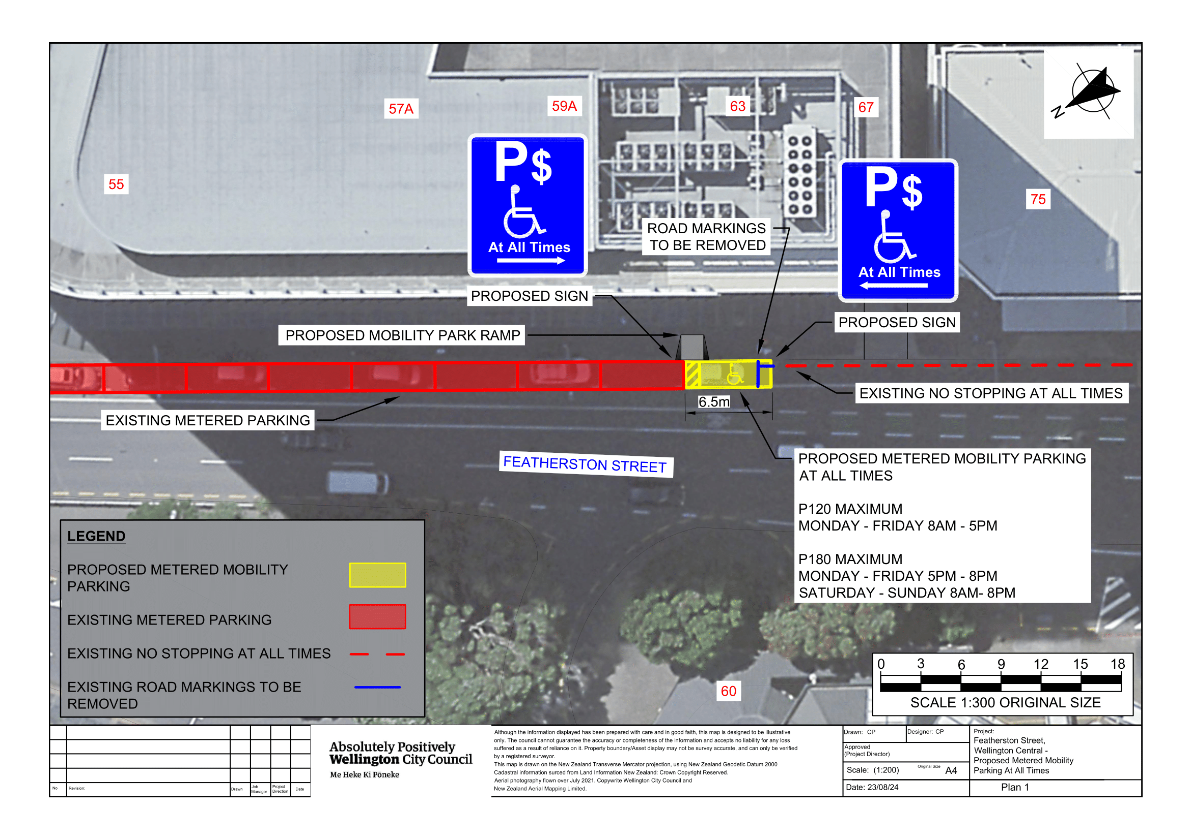

Legal Description:

Delete from Schedule D (No Stopping) of the Traffic Restrictions Schedule

Column One | Column Two | Column Three
Featherston Street | No Stopping  At All Times | East side, commencing 77.5 metres south of its intersection with Bunny Street (Grid coordinates x= 1749003.7 m, y= 5428664.8 m), and extending in a southerly direction following the eastern kerbline for 5 metres.

Delete from Schedule F (Metered Parking) of the Traffic Restrictions Schedule

Column One | Column Two | Column Three
Featherston Street | Metered Parking,  P120 Maximum, Monday to Thursday 8:00am - 6:00pm, Friday 8:00am - 8:00pm, Saturday and Sunday 8:00 - 6:00pm | East side, commencing 16.5 metres south of its intersection with Bunny Street (Grid coordinates x= 1749003.7 m, y= 5428664.8 m), and extending in a southerly direction following the eastern kerbline for 61 metres (10 parallel parking spaces).

Add to Schedule B (Class Restricted) of the Traffic Restrictions Schedule

Column One | Column Two | Column Three
Featherston Street | Metered Mobility Parking At All Times,  P120 Maximum, Monday to Friday 8:00am – 5:00pm  P180 Maximum, Monday to Friday 5:00pm – 8:00pm, Saturday to Sunday 8:00am – 8:00pm | East side, commencing 72 metres south of its intersection with Bunny Street (Grid coordinates x= 1749003.7 m, y= 5428664.8 m), and extending in a southerly direction following the eastern kerbline for 6.5 metres (1 parallel parking spaces).

Add to Schedule D (No Stopping) of the Traffic Restrictions Schedule

Column One | Column Two | Column Three
Featherston Street | No Stopping  At All Times | East side, commencing 78.5 metres south of its intersection with Bunny Street (Grid coordinates x= 1749003.7 m, y= 5428664.8 m), and extending in a southerly direction following the eastern kerbline for 4 metres.

Add to Schedule F (Metered Parking) of the Traffic Restrictions Schedule

Column One | Column Two | Column Three
Featherston Street | Metered Parking,  P120 Maximum, Monday to Friday 8:00am – 5:00pm  P180 Maximum, Monday to Friday 5:00pm – 8:00pm, Saturday to Sunday 8:00am – 8:00pm | East side, commencing 16.5 metres south of its intersection with Bunny Street (Grid coordinates x= 1749003.7 m, y= 5428664.8 m), and extending in a southerly direction following the eastern kerbline for 55.5 metres (9 parallel parking spaces).

Prepared By: | Charlotte Poi | (Transport Engineering Assistant)
Approved By: | Kate Gourdie | (Team Leader Traffic & Resolutions)
Approved Date: | 4/9/2024

